**INTRODUCTION**

1. **INTRODUCTION**

In the age of accuracy and high speed it has given a tremendous boost to explain the potential of the computers, in the field of data processing. The facilities of the computers are being utilized in the number of data processing applications. The objective of this project is to utilize the facilities of the computers for the data processing in the firms for their daily requirements. This project is aimed at developing a application and central recruitment Process system for the HR Group for a company. Some features of this system will be creating vacancies, storing application data, and Interview process initiation, Scheduling interviews, storing Interview results for the applicant and finally Hiring of the applicant. Reports may be required to be generated for the use of the HR group.

This project ‘AUTOMATION OF MAN POWER CONSULTANCY **’** is an application in which jobseekers can register and then attend the exam. Based on the outcome of the exam the jobseekers will be short listed. For fresher, the exam will be conducted at some venue after short listing of the preliminary Aptitude Test. The details of the examination, venue & Date of the examination will be made available to them through the application.

* 1. **ORGANIZATION PROFILE:**

Attest is a leading service provider that offers complete technology-based contemporary assessment solutions.

Attest assists organizations in implementing innovative assessments that enhance performance, ensuring reliability & security in a cost-effective manner using computer-based and paper-pencil mode of delivery.

With over 7 years of experience in delivering computer-based assessments, Attest delivers tests anytime, anywhere through a national network of authorized testing centres.

To date, Attest has successfully delivered more than 3.5 million tests.

**Services**

* 7 years' experience
* 3.5 million assessments conducted, so far
* Network of 67 Attest Authorized Test Centers (AATC) across India & abroad
* Enabling 24/7 test delivery
* Conduct online, paper-pencil tests, or both
* Test delivery modes: Via Internet, Attest own server, via portable server for offsite tests
* End-to-end assessment solutions
* Large-scale delivery capability
* National network of test centres
* Multiple modes of delivery

## Security

* ISO 27001 certified
* Secure FTM
* Complete proctoring
* Network traffic, Server audit logs
  1. **EXISTING SYSTEM:**

Presently recruitment is done manually. That is if a company or organization needs employees they make an announcement through newspaper. People who are eligible send application to the organization or company. From these applications they are called for interviews or tests. After tests company has to do short listing manually. From these shortlisted candidates, they are called for interviews. After interview short listed candidates are employed. So it’s all a time consuming procedure.

**LIMITATIONS OF EXISTING SYSTEM**

Recruitment is done manually. These tasks are time consuming. It may take one month or long.

CGPU system is very convenient because in the manual system there are lots of difficulties in conducting and managing a recruitment exam, short listing, maintaining staff etc.

* 1. **PROPOSED SYSTEM:**

CGPU is aimed at developing a computerized recruitment process system for the HR Group for a company. Some features of this system will be creating vacancies, storing application data, and Interview process initiation, Scheduling Interviews, Storing Interview results for the applicant and finally hiring of the applicant. Based on the outcome of the exam the jobseekers will be shortlisted.

**ADVANTAGES OF PROPOSED SYSTEM**

CGPU enables the users to have the typical examination facilities and features at their disposal. It resolves typical issues of manual examination processes and activities into a controlled and closely monitored work flow in the architecture of the application. This solution brings in by default, the basic intelligence and immense possibilities for further extension of the application as required by the user. The system makes it friendly to distribute, share and manage the examination entities with higher efficiency and easiness.

* 1. **FEASIBILITY STUDY**

The objective of the feasibility study is not only to solve the problem but also to acquire a sense of its scope. The reason for doing this is to identify the most beneficial project to the organization.

There are three aspects in the feasibility study:

* Technical Feasibility
* Financial Feasibility
* Operational Feasibility

**TECHNICAL FEASIBILITY:**

The Technical feasibility is the study of the software and how it is included in the study of our project. Regarding this there are some technical issues that should be noted they are as follows

The technical issues are raised during the feasibility study of investigating our System. Thus, the technical consideration evaluates the hardware requirements, software etc. This system uses VB as front end and MS-ACCESS as back end. They also provide sufficient memory to hold and process the data.

As the company is going to install all the process in the system it is the cheap and efficient technique.

This system technique accepts the entire request made by the user and the response is done without failure and delay. It is a study about the resources available and how they are achieved as an acceptable system. It is an essential process for analysis and definition of conducting a parallel assessment of technical feasibility.

Though storage and retrieval of information is enormous, it can be easily handled by MS Access. As the Access can be run in any system and the operation does not differ from one to another. So, this is effective.

**FINANCIAL FEASIBILITY:**

An organization makes good investment on the system. So, they should be worth full for the amount they spend in the system. Always the financial benefit and equals or less the cost of the system, but should not exceed the cost.

* The cost of investment is analyzed for the entire system
* The cost of Hardware and Software is also noted.
* Analyzing the way in which the cost can be reduced.

Every organization wants to reduce their cost but at the same time quality of the service should also be maintained. The system is developed according the estimation of the cost made by the concern. In this project, the proposed system will definitely reduce the cost and also the manual work is reduced and speed of work is also increased.

**Operational Feasibility:**

Proposed project will be beneficial only when they are turned into an information system and to meet the organization operating requirements.

Issues that may be a minor problem will sometimes cause major problem in the operation. It is the measure of how people can able to work with the system. Finding out the minor issues may be the initial problem of the system. It should be a user-friendly environment. All these aspect should be kept in mind and steps should be taken for developing the project carefully.

Regarding the project, the system is very much supported and friendly for the user. The methods are defined in an effective manner and proper conditions are given in other to avoid the harm or loss of data. It is designed in GUI interface, as working will be easier and flexible for the user. They are three basic feasibility studies that are done in every project.

**OVERVIEW OF THE PROJECT**

1. **OVERVIEW OF THE PROJECT**

After studying the present manual system a planned manual system, a planned computer based system is proposed. The proposed system will take care of all the necessary and sufficient information required for the effective maintenance of accounts. The scope of the project involves development of the processes related to the accounts for each transaction. The application can be used for every firm that wants to be computerized.

The project will be very useful to handle all the situations very efficiently. The form is used to get information from the user and until he will not fill the all required information in correct format he would not be able to do transaction. Also the calculations are very easy to perform, within only a few seconds a person can calculate that if handled manually will take a few days. Also list of account can be seen as per the requirements. Cleanliness also can be maintained in the record keeping whenever some updates are required, the old information is deleted and instead of that old information the new is written. Computerized firms will also not cause frustration to the customer, as they will get the quick responses.

This project ‘job seeker’s portal’ is an application in which jobseekers can register themselves and then attend the exam. Based on the outcome of the exam the jobseekers will be short listed. For fresher, the exam will be conducted at some venue after short listing of the preliminary aptitude test. The details of the examination, venue & date of the examination will be made available to them through the application.

This application is about storing information about applicants, companies and placements of various applicants in various companies. It contains three modules. First module is about applicants in which we maintain information about applicants like applicant name, their qualification  , the post for which they have applied. Second module is about storing information about companies like their name , the kind of employees they have demanded . Third module is about storing information about applicants who have been placed in companies , and the charges , they have paid to company.

**MODULES DESCRITION:**

**ADMINISTRATOR:**

Administrator has the full authority over the application. He can view all the registered users and have the power to delete them. He can edit the details and update them. He can view all the company details also.

**Maintenance And Administration**

The Module Will Provide An Easy And Simple Method Of Updating Information Related To Candidates. The Administrator Will Be Able To Use Every Option For Updating Or Deletion. It Includes:

Creating New Users For The System & Employee Details And Making Accounts With Access Codes(Passwords). Through These Access Codes, Users Will Interact With The Tas. These Access Numbers Will Be Unique And Confidential. Maintaining Separate Tables That Will Store Data Related To:

* Various Transactions Done By The Firm
* Candidate details
* Exam details

**JOBSEEKER:**

A jobseeker can register him. After registration, he will be directed to his window. Here he can update his profile, change password and see the examination details and all.

**COMPANY:**

A company can register it, conduct examination, approve or disapprove candidates attending examination and provides results about the selected candidates.

**SYSTEM STUDY**

1. **SYSTEM STUDY**
   1. **HARDWARE SPECIFICATION:**

CPU type : PENTIUM IV

Clock Speed : 1.8 GHz

Ram : 2GB

Key Board : Standard 103 keys

Mouse : Standard Mouse

Hard Disk : 500 GB

* 1. **SOFTWARE SPECIFICATION:**

Operating System : WINDOWS 7

Front- End : Visual Basic 6.0

Back-End : MS-Access

* 1. **SOFTWARE DESCRIPTION:**

**VISUAL BASIC**

Visual basic is an event-driven programming language with numerous features that made application development an easy task. Data access features allow you to create database and front-end applications for most popular database formats. Active X technologies allow you to use the functionality provided by other applications, such as Microsoft word, Microsoft excel, and other windows applications can even automate applications and objects created using the professional or enterprise editions of visual basic. Internet capabilities make it easy to provide access to documents and applications across the Internet from within your application. Your finished application is a true executable file that uses run-time dynamic-link library (DLL) which you’re freely distributes.

**THREE EDITIONS OF VISUAL BASIC:**

Visual Basic is available three editions, each graded to meet a specific set of developments requirements. The visual basic learning edition of standard edition allows programmers to easily create powerful applications for Microsoft Windows 95 and window NT. It includes all intrinsic controls, plus grid, tab, and data-bound controls.

The learning edition of visual basic incorporates a limited subset of the jet engine’s data access capabilities in the data control and social data-bound controls. These features allow you to access existing data bases, but do not provide for creating new databases or data access objects.

The professional edition provides computer professionals with a full-featured set of tools for developing solutions for other. It includes all the features of the learning edition plus additional Active X controls, including Internet controls, and Crystal Report Writer. It also includes all of the data control features, and full data access objects programming interface. The enterprise edition allows professionals to create robust distributed applications team setting. It includes all the features of the professional edition, plus the information manager, component manager, database management tools, the Microsoft visual source safe Tm project-oriented version control system and value.

The enterprise edition adds a number of powerful client/server tools to visual Basic’s data access capabilities. Including the Remote Data Control specifically designed to access remote ODBC client/server data bases

**HARDWARE AND SYSTEM REQUIREMENTS:**

To run visual basic, you must have certain hardware and software installed on your computer. The system requirements include Microsoft Windows NT 3.51or later, or Microsoft Windows 95 80486 or higher microprocessor.

* A hard disk with a minimum of 50 megabytes available space for a full installation.
* A CD-ROM disc drive (optional)
* 16MB of RAM
* A mouse or other suitable pointing device. The visual basic integrated development environment (IDE) consists of the following elements.

**SDI OR MDI INTERFACE:**

Visual Basic set to Multiple Document interface-MDI (discussed later) mode by default. To change to the single document mode-SDI mode follows the steps given below. We will be working in the SDI mode all of the IDE windows are free to by move where on screen as long as visual basic is the current application, they will remain on top of any other applications.

To switch between SDI and MDI modes

* Select options from the Tools menu. The options dialog box is displayed
* Select the advanced tab
* Check the SDI Development Environment check box to start in the SDI mode by default.

**Note:**This setting would take effect only the next time you start Visual Basic.

By now you should be comfortable identifying the many windows on the screen. Before we begin working with these controls let us understand Visual Basic’s approach to programming.

Programming in Visual Basic is object based. Here the focus is on the object. What is the object, the basic attributes of the (properties) how the user interacts with the object (events) and the actions in Visual Basic can defined as combination of code and data that can be treated as one unit. An object can be an entire application or a piece of an

application like a form or a control on a form e.g. a text box or a label a database or a chart is some other examples of objects.

**PROPERTIES:**

Properties can be thought of as and objects attributes which define the appearance of the object like the size and color.

Events: Events are the responses which are triggered when the user interacts with the object at the time the program is executing e.g. a click, double click or drag.

**METHODS:**

Methods are actions that define the behavior of any object. E.g. move or save.

Therefore objects have properties, they respond to event and perform methods (action) you can use objects provided by Visual Basic to control other application’s objects room within your visual basic applications, as well as create your own objects, and define additional properties and methods for them. Given below is a brief expression of all default visual basic objects/controls each of these objects/controls have their own set of properties, events, and methods with while you can control their appearance and behavior.

**ACTIVE X CONTROL:**

An Active X control is an extension to the Visual Basic toolbox. Active X control has the file name extension OCX. You can use the Active X controls provided with Visual Basic 5.0 or obtain additional controls from third-party developers. Visual Basic Active X controls are 32-bit controls. Some third-party developers offer Active X controls which 16-bit controls, and these cannot be used in Visual Basic version 5.0. You use Active X controls just as you would use any of the standard built-in controls, such as the Check Box control. When you add an Active X control to program, it becomes part of the development and runtime environment and provides new functionality for your applications.

Active X controls leverage your capabilities as a Visual Basic programmer by retaining some familiar properties, events, and methods, such as the name property, which behave, as you would expect. Also the Active X controls feature methods and properties that greatly increase your flexibility and capability as a Visual Basic programmer.

**DATA CONTROL:**

The data control provides a relational interface to database files. Basically, a relational database is one that stores data of tables made up of columns and rows of data. In Visual Basic, columns are referred to as fields, and rows are referred to as records.

The Microsoft jet database engine that powers the data control views all databases as a set of relational tables, regardless of their physical file format. This means that when you use data from external databases (such as FoxPro, paradox, dBase, Microsoft   
Excel, Lotus 1-2-3 Text, or ODBC), you can use the same relational terms.

**TABLES:**

A table is a logical grouping of related information arranged in rows and columns, similar to a spreadsheet table might contain a list of information about authors, such as their names date of birth, addresses, and pictures.

**FIELDS:**

Each column in a database table is called a field. Tables are defined by the fields they contain, with each field describing the date it is to hold. When creating a database, you assign a data type, maximum length, and other attributes to each field. Fields can contain characters, numbers, or even graphics. For example, the Authors table might have fields with the name and address as data type characters, the date of birth as data type date, and the author’s photograph as type graphic.

**RECORDS:**

Information about individual authors is kept in the rows of the table, called records. Generally, database table records are created such that no two rows are the same.

**INDEXES:**

To make access to the data faster, most databases use indexes. Database table indexes are sorted lists that are faster to search than the tables. Each index entry points back to the database row it references. If the database (which do all of the searching) can look through an index first when looking for records (performing a query), its job is made easier and your data is returned faster.

**UNDERSTANDING RECORD SET:**

Visual Basic version 5.0 retrieves and displays database records using the recordset object provided by the Microsoft jet database engine, version 3.5. A record set object represents the records in a base table or the records that result from running a query. The following tables list the three types of recordset objects available on the data control.

**RECORD TYPE DESCRIPTION:**

Table-type Recordset (dbOpen Table) A set of records that represents a single Database table that you can use to add, change, or delete records, Dynaset-type Recordset (dbOpenDynaset) A dynamic set of records that represents a database table or the results of a query containing fields from one or more tables. You can add, change, or delete records from a dynasettype Recordset and the changes will be reflected in the underlying table(s).

Snapshot-type Recordset (dbopenSnapshot) is a static copy of a set of records that you can use to find data or generate reports. A snapshot-type Recordset can contain fields from one or more tables in a database but can’t be updated. You can choose the type of Recordset object that you want the data control to create using the Recordset Type property. The default values vbDynaset Type.

Dynaset-and snapshot-type of Recordsets is stored in local memory. If you don’t need your application to select fields from more than or set table, and you are working with a non-ODBC source, the table-type. Recordset may be the most efficient in speed and memory use and in local TEMP disk space Recordset objects created in code (not available in the Visual Basic, learning Edition) can be assigned to the Recordset property of the data control using the set Statement Set Data1.Recordset.MyRecordset. Similarly Recordset object created by one data control can be assigned to another data control at runtime.

The jet database engine provides a large number of database and recordset properties and methods. You can these properties and methods directly with the data control by referring to data control’s database and recordset properties.

**ACCESSING DATA:**

Almost all applications require some form of data storage and manipulation, and visual basic provides a number of tools to meet these needs, including the data control and data-bound controls data access objects remote data objects, and remote data control.

This chapter focuses on the tools available in all editions of Visual Basic- The data control and data-bound controls. For stand-alone desktop applications, these tools are easy to use with little or no programming and allow you to create and access databases in a number of popular formats.

**DATA ACCESS OPTIONS:**

You can use the data controls to create applications that display, edit, and update information from many types of existing databases, including Microsoft Access, Brief, dBase, Microsoft Excel, Lotus 1-2-3, and standard ASCE text files as if they were true databases. In addition the data control allows you to access and manipulate remote Opendatabase connectivity (ODBC) databases such as Microsoft SQL

**DATA ACCESS CONTROLS:**

You can use the data control to create simple database applications without writing any code at all. You can also use it together with Visual Basic code to create full-featured applications that give you a high degree of programming control over the behavior of your application’s data. This topic will present more complex programming examples.

The data control can perform the following tasks without the use of code:

* + Connect to a local or remote database
  + Open a specified database table or define a set of records based on a Structured Query Language (SQL) query of the tables in that database.
  + Pass data fields to bound controls, where you can display or change the values.
  + Add new records or update a database based on any changes you make to data displayed in the bound controls.
  + Trap errors that occur as data is accessed.
  + Close the database

To create a database application, you add the data control to your forms just as you would any other Visual Basic control. You can have as many data controls on your form

as you need. As a rule, you will use one data control for each database table that you need to manipulate.

**CREATING A SIMPLE DATABASE APPLICATION:**

The following procedure gives you a brief overview of how to use the data control in a Visual Basic application. The example uses the Biblio.mdb sample database supplied with visual basic.

**TO USE THE DATA CONTROL IN AN APPLICATION:**

Select the data control in the Toolbox, and draw a data control on a form. After you draw the control on the form and size it, the caption appears as the default name of the control as Data1.

1. In the properties window, set the connect property to the type of database you want to use.
2. In the properties window set the database name property to the file or directory name of the database to which you want to connect. If your database is not available at design time, you will need to fill in the database name and record source properties at runtime.
3. Set the record source property to the name of the database table you want to access.
4. If the database is currently available, you can select a table from the dropdown list in the property window. If your database could not be found, the drop-down list will not appear in the record source settings box and an error message will appear.
5. Draw a text box on the form to display the database information. This control will be used to display and edit a selected field from the database. You can also use other data-bound controls including check boxes, picture boxes, image controls, labels, list boxes, combo boxes, and grid controls.
6. In the properties window, set the data source property for text1 to the name of the data control (data1). This binds the text box to the data control.
7. Add label and set its caption property to the name of the database field this text box will expose.
8. Set the data field property for text1 to the name of the field in the database table you want to view or modify.
9. Repeat steps 4,5,6,7 and 8 for each additional field you want to access. In the following example, the title, ISBN, and year published fields have been selected from the titles table.
10. Now run the application. You can use the four arrow buttons on the data control to move to the beginning of the data, to the end of the data, or from record to record through the data. You can modify the information in the database by changing the value displayed in any of the bound controls. When you click a button on the data control to move to a new record, Visual Basic automatically saves any changes you have made to the data.

Of course, you can add code to enhance your application further. The rest of this chapter shows you how to use the data control with bound controls to manipulate data, examine the structure of the database, and write event procedure to handle events that occur as data is accessed or updated.

**USING THE DATA BOUND CONTROLS:**

Data bound controls are the data-aware controls through which you access information in a database. When a control is bound to the data control, Visual Basic applies field values from the current database record to that control. In turn, the control displays data to you and accepts your changes. If you change data in a bound control, those changes can be automatically written to the database as you move to another record.

Most bound controls are characterized by three data aware properties:

* Data changes,
* Data field,
* Data source

**PROPERTY DESCRIPTION**

Data Changed Indicates whether a value displayed in abound

Control has changed.

Data field Specifies the name of a field in the recordset

Created by the data control.

Data source Specifies the name of the data control to which

The control in bound.

The steps in adding bound controls to your application are:

* Draw the bound control the same form as the data control to which it will be bound.
* Set the Data Source property to specify the data control to which it will be bound.
* Set the Data Field property to a valid field in the data control is records.

If the database is available at design time a list of valid fields will be displayed in the Data Field Settings box in the property window. If the database is not available at design time, you will need to provide a valid field name at run time before data values will be posted to the control from the database.

You can have more than one bound control for a particular field but you do not need to provide a bound control for each field in the table. Neither the data control the bound controls need to be made visible. So you can incorporate data access capabilities into any form you design, manipulating the data control behind the scenes with Visual Basic code.

When you run your application the data control works together with the database to give you access to the current set of record, or records, with which you are working.

Using the arrow buttons on the data control, you can move from record to record and using the Bound Controls, you can view or edit the data displayed from which field. Whenever you click a button on the data control, Visual Basic automatically updates any changes you have made to the record set.

With Visual Basic code, it is also possible to use data-bound controls without binding them to control, using the DataBindings collection of the bound control.

**TYPES OF BOUND CONTROLS:**

Visual Basic supports several built-in (intrinsic) controls that you can bind to the Data control, as well as several Data-Bound Active X (. OCX) controls (formally called custom or OLE controls). Many other data-aware controls are available from third parties and in the professional and Enterprise editions of Visual Basic.

**STANDARD/INTRINSIC CONTROLS:**

The standard Bound Controls that you can use with the Data Control include the Check Box, Image, Label, Picture Box, Text Box, List Box, Combo Box, OLE container Control.

**ABOUT MS ACCESS**:

Before we look at the access software and its capabilities, let us first understand what a database is, and what is meant by a relational database management system, or RDBMS as it is popularly called dictionaries, phone books and even shopping catalogues are all example of common database you probably use on regular basics. What qualifies these documents as database? Why it a novel or a magazine not a database.

**DATA BASE:**

A Database is an organized list of data (information) that can be queried to find information quickly and easily based on a chosen reference point, such as a last name or a social security number. On the other hand, a collection of information, such a report in a newspaper organized around a simple reference point, and does not allow systematic access. Therefore a report in a newspaper does not quality as a database.

The most common organization of a database is a series of rows and columns filled in with information and laid out in such a manner that any specific piece of information is easily available. Typically, database columns consist of a heading that describes the type of information it contains, and each row contains the requisite information. In database terminology, the columns are called fields and the rows are called records. This kind of organization in a database is called a data table, or just a table.

MS-Access is a relational Database Management System (RDBMS) that you can use to store and manipulate large amount of formation. A relational database is a database, which consists of tables of related information that are linked together based on key field. The tools of access are user friendly and provide at a powerful development environment, making it equality appropriates for novice and MIS professionals. For example, you can use access to quickly and easily create a database of mailing information that you can merge with word document.

**MAIN ELEMENTS OF ACCESS:**

Access is an object-oriented program. Objects are modules, which provide information and programs, which the user can directly apply to create applications. Everything in access is an object, including the applications itself. Each object has properties that define how the object looks and perform. Access has the following objects

**DATABASE WINDOWS:**

In access, all objects of a database are stored in a single file and the file name has an MDB extension. These objects are managed through the database window.

**TABLES:**

Tables are the primary building blocks of the access database. All data is stored in tables. Every table in the database focuses on one object for example, customer, order or products. Every row or record in the table is a unique instance of the subject of the table.

**QUERIES:**

A query is a question that you ask of the data that stored in the tables of your database. For example, you can create query that only asks for the customers who reside in the state of California, or one that finds all employees who have birthday in the current month.

**FORMS:**

Forms present the data form a table or a query in the way you want it to be represented. The fields in the tables or query are made available to a place on the forms to create. You can edit the form as just as you can would edit a data sheet bound table or query.

**REPORTS:**

Whether we like it or not, we are still a paper based society, printing the results the data. Reports are still necessary. With access, you quickly and easily design reports based on your data.

**MODULES:**

Modules are the containers for any programming code written in an access database. The two types of modules in the access database are global and form, or report.

**SYSTEM DESIGN**

1. **SYSTEM DESIGN**

Design focuses the detailed implementation of the system. It is a “how to approach” to the creation of a new system. The important phase is composed of several steps. It provides the understanding and procedural details necessary for implementation of system.

Emphasis must be laid on translating the performance requirements into design specification. Design goes through logical design reviews the present physical system prepares input and output specifications. The physical design maps out the details of the physical system and the system implementation.

* 1. **INPUT DESIGN:**

The Data, which is input to a computer-based information system, must be correct. If data is carelessly input and errors enter the system, it will lead to incorrect results whose sequences will be expensive and embarrassing to the designer. Hence, one of the important tasks of a system designer is to ensure that the design prevents such errors. An important point to be remembered by the designer is that the volume of input data in information systems is very large.

This implies that, when an error occurs, it will take a long time to find out the source of the errors unless the design includes controls to isolate a subset of the errors unless the design includes controls to isolate a subset of data records as the source of the error.

The input design is the link that ties the information system into the world of its users. It consists of developing specification and procedures for data preparation, those steps necessary to put transaction data into a usable form for processing.

Data entry can be achieved by instructing the computer to read data from a written or printed document or it can occur by having people token in data discretely into the system. The design of inputs focuses on controlling the amount of output required, avoiding delay, controlling errors and keeping the process simple.

**DATA INPUT:**

The input of data to a computer can be either on-line or off-line. In online data entry the user directly enters data into the computers secondary storage, namely a disk file. This entry is through a terminal connected to the computer. In this method the computer prompts with a menu or commands, or form a displayed on the video display. Any errors in data entry are checked immediately and the suitable message will be sent within one or two seconds to correct the input data.

In the figure illustrated, a data validation program checks the data entered by operators and data records with errors are printed in the error report. The incorrect transactions in the input are corrected and the data is entered again. A file update program to update the form in which the data is manually entered uses the correct transactions. In the form design, the chances of mistakes in data entry should be minimized. The following points should be kept in mind while designing forms:

* Leave enough space for writing legibly the information.
* Give clear instruction to fill the form. The instruction is in front of the line where the data is to be entered.

**CONTROLLING AMOUNT OF INPUT:**

There are several reasons why an effective design should control the quantity of data preparation and data for input. First, data preparation and data entry operations depend on people. Because the labor costs are high the cost of preparing and entering the data is also high. Reducing data requirements can lower the cost by reducing labor expense.

The input phase of computing can be a slow process that can take longer period than the period needed by computers to carry out their tasks. In fact, the computer may sit idle while data are being prepared and input for processing. By reducing input requirements, the analyst can speed the entire process data capturing to providing results to users.

**AVOIDING ERRORS IN DATA:**

The rate at which error occurs depends on the quantity of data, since the smaller the amount of data to input, the fewer the opportunities for errors. Yet the analyst can reduce numbers of errors by reducing the volume of data that must be entered for each transaction.

The analyst can also affect the error rates of an operation through input design, since the manner in which data must be entered can affect the incidence of errors. Since another aspect of error control is the need to detect errors when they do occur.

Input file

Data entered in forms

Error

Report

Data Base

Output

Report

* 1. **OUTPUT DESIGN:**

Resenting the data processed by a computer – based information system in an attractive and usable form is very important. Very often the success and acceptance of systems depends on good output presentation. It is thus essential for a system analyst to understand how to design output reports. Currently excellent graphic displays are widely in use.

One of the most important features of a system is the output it produces. Without the quality output, the entire system may appear to be unnecessary that users will avoid using it, possibly causing it to fail.

Designing computer output should proceed in an organized well thought-out manner. The right output must be developed while ensuring that each output element is designed. When the analyst designs the computer output, the following things should be taken into consideration.

1. Identify the specific output is needed to meet the information requirements
2. Select methods for presenting information.
3. Create document, report or other formats that contain information produced by the system.

For many end users, output is the main reason for developing the system and the basis on which they evaluate the usefulness of the application. Most end users will not actually operate the information, system or the workstations, but they will use the output from an information system should accomplish one or more of the following objectives.

* 1. **DATABASE DESIGN:**

A Database is a collection of interrelated data stored with minimum redundancy to serve the company quickly and effectively. The general objective is to make information access easy, quickly, inexpensive and flexible for the used. In data base design several specific objectives are considered.

A set of fundamental software design concepts has evolved over the past three decades. Although the degree of interest in each concept has varied over the years, each has stood the test of time .Each provides the software designer, with a foundation from which more sophisticated design methods can be applied.

Database design is used to define and then specify the structure of business objects used in the client/Server System. The analysis required to identify business objects is accomplished using information- engineering methods. Conventional analysis modeling notation, Such as the **ERD,** can be used define business objects but a database repository should be established to capture the additional information that cannot be fully documented using the graphical notation such as ERD

In this repository, a business object is defined as information that is visible to the purchasers and users of the system, not its implementers. Each entity identified in the ERD is expanded during design into a data structure - all definitions governing files, relationships among data items in the records of the file, validation rules of these relationships, and business rules that specify the external view of the processing that is to occur for the data.

A wide array of design information must be developed during database design. This information, implemented using a relational database, can be maintained in a design repository modeled. Individual tables are used to define the following information for the client / Server database.

**NORMALIZATION**

Normalization theory is the study of relations (tables), attributes (columns), and the dependency of attributes upon one another.

The goals of normalization include the following:

* Minimizing redundant data
* Avoiding update anomalies
* Reducing inconsistent data
* Designing data structures for easier maintenance
* All columns should contain a single piece of information.
* All columns depend only on the primary key.

**FIRST NORMAL FORM:**

This is in the basic level of normalization and generally corresponds to the definition of any database, namely:

It contains two-dimensional tables with rows and columns

Each column corresponds to a sub-Object or an attribute of the object represented by the entire-table.

Each row represents a unique instance of that sub-object or attribute and must be different in some way from any other row (that is, no duplicate rows are possible)

All entries in any column must be of the same kind.

**SECOND NORMAL FORM:**

At this level of normalization, each column in a table that is not determines of the contents of another column must itself be a function of the other columns in the table.

In this system, all the tables contain primary key and all the non-key attributes are functionally dependent on key attribute.

**THIRD NORMAL FORM:**

To be in third normal form, a table’s columns must be entirely dependent on the primary key. The key word in that sentence is entirely .Each column in the table must be dependent on the entire primary key, not just a portion of it.

At the second normal form, modifications are still possible because a change to one row in the table may affect data that refers to this information from another table. In third normal form, these tables would divide into two tables so that some data would be tracked separately.

**DOMAIN KEY / KEY NORMAL FORM (DKNF)**

A key uniquely identifies each row in a table. A domain is the set of permissible values for an attribute. By enforcing key and domain restrictions, the database is assigned of being freed from modifications anomalies. DKNF is the normalization level that most designers aim to achieve.

**DATA DICTIONARY:**

A Data Dictionary as a structured repository of data about. It is a set of rigorous definitions of all DFD data elements and data structures. A data dictionary has many advantages. The most obvious is documentation; it is a valuable reference in any Organization. Another is, including analyst definitions of various element Terms and Procedures.

During implementation, it serves as a common base against which programmers, who are working on the system, compares data description references in a data dictionary, which makes it easy identify them and make any necessary changes.

Also control information maintain for each data elements is cross references in a data dictionary , which makes it easy identify them and make any necessary changes.

**DATABASE TABLES:**

**TABLE NAME: USERLOGIN**

|  |  |
| --- | --- |
| **FIELD NAME** | **TYPE** |
| USERNAME | TEXT |
| PASSWORD | TEXT |

**TABLE NAME: ADMIN LOGIN**

|  |  |
| --- | --- |
| **FIELD NAME** | **TYPE** |
| USERNAME | TEXT |
| PASSWORD | TEXT |

**TABLE NAME: ADDQUES**

|  |  |
| --- | --- |
| **FIELD NAME** | **TYPE** |
| BRANCHCODE | TEXT |
| EXAMTYPE | TEXT |
| EXAMCODE | TEXT |
| EXAMID | TEXT |
| QNO | NUMBER |
| QST | TEXT |
| CH1 | TEXT |
| CH2 | TEXT |
| CH4 | TEXT |
| ANS | TEXT |

**TABLE NAME: NEWBRANCH**

|  |  |
| --- | --- |
| **FIELD NAME** | **TYPE** |
| BRANCHNAME | TEXT |
| BRANCHCODE | TEXT |
| EXAMTYPE | TEXT |

**TABLE NAME: APPLY EXAM**

|  |  |
| --- | --- |
| **FIELD NAME** | **TYPE** |
| REGNO | NUMBER |
| FIRSTNAME | TEXT |
| LASTNAME | TEXT |
| DOB | TEXT |
| BRANCHNAME | TEXT |
| EXAMTYPE | TEXT |
| EXAMNAME | TEXT |
| EXAMCODE | TEXT |
| EXAMDATE | DATE/TIME |
| EXAMTIME | TEXT |

**TABLE NAME: EXAM DETAILS**

|  |  |
| --- | --- |
| **FIELD NAME** | **TYPE** |
| BRANCHCODE | TEXT |
| EXAMTYPE | TEXT |
| EXAMCODE | TEXT |
| EXAMID | TEXT |
| EXDATE | DATE/TIME |
| TIME | NUMBER |

**TABLE NAME: NEW USER**

|  |  |
| --- | --- |
| **FIELD NAME** | **TYPE** |
| FIRSTNAME | TEXT |
| LASTNAME | TEXT |
| GENDER | TEXT |
| DOB | TEXT |
| MOBNUMBER | TEXT |
| EMAILID | TEXT |
| MOTHERNAME | TEXT |
| FATHERNAME | TEXT |
| TEMPADDRESS | TEXT |
| PERMADDRESS | TEXT |
| SSLCPER | TEXT |
| HSCPER | TEXT |
| DIPPER | TEXT |
| UGPER | TEXT |
| PGPER | TEXT |
| OTHERDETAIL | TEXT |
| IDPROOF | TEXT |
| IDVALUE | TEXT |
| PHOTO | TEXT |
| SIGN | TEXT |
| USERNAME | TEXT |
| PASSWORD | TEXT |
| RGNO | NUMBER |

**TABLE NAME: NEWEXAM**

|  |  |
| --- | --- |
| **FIELD NAME** | **TYPE** |
| BRANCHCODE | TEXT |
| EXAMTYPE | TEXT |
| EXAMNAME | TEXT |
| EXAMCODE | TEXT |

**TABLE NAME: RESULT**

|  |  |
| --- | --- |
| **FIELD NAME** | **TYPE** |
| USERNAME | TEXT |
| BRANCHCODE | TEXT |
| EXAMTYPE | TEXT |
| EXAMCODE | TEXT |
| EXAMID | TEXT |
| MARK | NUMBER |
| RESULT | TEXT |

**TABLE NAME: UPLOAD**

|  |  |
| --- | --- |
| **FIELD NAME** | **TYPE** |
| REGNO | NUMBER |
| FIRSTNAME | TEXT |
| LASTNAME | TEXT |
| DOB | DATE/TIME |
| ADDRESS | TEXT |
| EXAMCENTERNAME | TEXT |
| EXAMTYPE | TEXT |
| EXAMNAME | TEXT |
| EXAMCODE | TEXT |
| EXAMDATE | TEXT |
| EXAMTIME | TEXT |
| PHOTO | TEXT |
| SIGN | TEXT |

* 1. **DATA FLOW DIAGRAMS:**

Data flow diagram is a graphical tool. It is used to describe and analyses the movement of data through a system – manual or automated. They focus on the data following into the system, between processes and in and out of data stores. This is a central tool and the basis from which the other components are developed. The system models are termed as Data Flow Diagram (DFD).

Developing a description of the system using the structured analysis follows a top-down process. A full description of a system actually consists of a set of DFD’s, which comprises of various levels. A level 0 DFD, also called as context model, represents the entire software element as single bubble with input and output data indicated by incoming and outgoing arrows. Each of the process represented at level 1 are sub functions of the overall system depicted in the context model.

**DFD SYMBOLS:**

1. A square defines a source or destination of system date.
2. An arrow identifies data flow-data motion. It is a pipeline through which information flows.
3. A circle represents a process that transforms incoming data flows in to outgoing data flows.
4. An open rectangle is a data store-data at rest or a temporary repository of data.

DFD describes what flow (logical) rather than how they are processed. So it is not dependent on hardware, software, data structure of file organization.

The following symbols are used in DFD and each symbol has its own meaning.

- Source or Destination

- Data Flow

- Process

**DIAGRAMS:**

Admin

Failed

Authorized

Invalid User

**DB**

Upload Hall Ticket

Administrator

Branch Details

Exam Details

User Information

Online Question

**DB**

**Reports**

**DB**

Online Test

Hall Ticket Download

Online Registration

Create User

User Login

Upload Hall Ticket

Reports

**Reports**

**SYSTEM IMPLEMENTATION**

1. **SYSTEM IMPLEMENTATION**

In this chapter system implementation is explained. Implementation plan, process and user manual are illustrated here.

**IMPLEMENTATION PLAN:**

Implementation is the state in the system where the theoretical design is turned into a working system. The most crucial stage in achieving a new successful system and in giving confidence on the new system for the users that will work efficiently and effectively. The system can be implemented only after thorough testing is done and if found to work according to the specification.

It involves careful planning, investigation of the current system and its constraints on implementation, design of methods to achieve the changeover, an evaluation of changeover methods apart from planning. Two major tasks of preparing the implementation are education, training of the users and testing the systems. System analysis and design efforts will be more for complex systems beings implemented. Based on policies of individuals’ organization an implementation coordinating committee has been appointed.

**IMPLEMENTATION PROCESS:**

The implementation process begins with preparing a plain for the implementation system. According to this plan, the other activities are to be carried out. In this plan, discussion has been made regarding the equipment, resources and how to test the activities. Thus a clear plan is preparing for the activities.

**EQUIPMENT ACQUISITION:**

One of the most important development activities is the code of programming. The system According to the above plan, the necessary equipment has to be acquired to implement the new system.

**USER MANUALS:**

Once planning has been completed the major effort of the computer department is to ensure that the user department consists of education and trained staff, as the system becomes more complex. The success of a system depends upon how they are operated and used. Thus the quality of training, the personnel is connected to the success of the system.

For this purpose system and user manuals are prepared. In system manuals, details about the forms and blocks triggers, which were used to develop them, were specified. In user manuals data flow diagrams, charts and screen formats are given. Also error messages associated were explained in details. The users were shown the success and they were taught how to operate the system. Live demonstration and visuals aids were used to teach them.

**SYSTEM TESTING**

1. **SYSTEM TESTING**
   1. **UNIT TESTING:**

It is one of the very important methods in testing. Without this testing the project will not be completed or anybody cannot say it is bug’ free software’s in using the real time all these tests must be done. On using the lower bound and upper bound must be very specific. The check will be done for the starting record and ending record. So, all the errors will be rectified.

When conditional loops are used if it is true the correct data in project and for false answer wrong data will be seen. If any error has occurred they have to be replaced and checked. So, the line of code will be reduced.

To see an efficient project for how many lines of code has written and how many errors have been occurred will be seen.

**TEST DATA:**

The data, which is using for the testing must be related to the project to and to that particular function. Otherwise the testing will be very problematic. The function will not coincide with the data. So that it will be considered as error has occurred in it but actually it is not so here there are two data typed will there.

1. Sampled data for project testing
2. Actual data for project testing

**SAMPLE DATA FOR PROJECT TESTING:**

This sample data will be much more similar to the data which is collected in analysis phase only. On studying the collected data by the questioning, preliminary investigation, and documentation, the sample data usage the imagination is necessary. Depending on it choose the sample data. Use this data the white box testing for database or for external testing and black box testing for the internal loops and conditions.

All this data will be inserted into the database through browsers only for two or three days. It will be give as for practice to the end user. When they are interacting with data, the errors will remove and checked. Most of errors will be removed by using sample data only.

**ACTUAL DATA USED FOR PROJECT TESTING:**

This actual data is nothing but the original data, which have been collected in the analysis phase. Through the preliminary investigation, documents interviews. After collecting the data it will be sorted in an order and then it will be sorted in some place. Now to making the testing of the project this actual data will be used.

Here for the two test methods the data will be considered and each function and modules will be checked. Here using the actual data it is given to end users to make trail on the project. So, they can acquire the real environment. On working like this if any errors are occurred they will be removed and corrected. This actual data will be used for each function correctly and it will be removed. Here the occurrences are written and depending upon the occurrences the data will be supplied to the each function.

* 1. **INTEGRATION TESTING:**

Integration testing is a systematic technique for constructing the program structure while at the same time conducting tests to uncover errors associated with interfacing. The objective is to take unit-tested modules and build a program structure that has been directed by design. Top-Down integration and Bottom-up integration are tested finally.

Here there are two testing methods are there. They are white box testing and black box testing. Now here there is small introduction about the testing methods.

**WHITE BOX TESTING:**

This is one of the testing methods. This will be tested at the outside environment, which means accessing the server. i.e. Accessing data from the database. This will check whether data is retrieved correctly or not will be seen.

The main error in white box testing will be occurred due to the database connectivity. Here MS ACCESS is used as backend database. Here for the project some tables are created. In the programs they have to be clearly specified.

Whenever inserting data, updating data and selecting data from the database the queries must be written carefully. The separation between the string and numeric must be shown. The client side validations will be written in Visual Basic so that the data entered data is numbered or string will be known. Sometimes to access data from the database, the server may not be in running position.

So the database engine must be always on. This has to be monitored properly. In this method only whether the server is on or not will be tested.

So this method is very important when handling with the database here the ODBC drivers must support all the requirements.

**BLACK BOX TESTING:**

This is another important test method will check only internal code loops, conditional loops will be checked. In the code if he is a particular user then only the user will get some privileges. So here comparison testing has been done. If there is any error has occurred an error message will be raised.

This method will check the loops like for loops for. Loops, repeat… while…all will be checked at their boundary conditions also. If the data at extreme conditions are correctly retrieved, there will be no error. If any error has occurred using some modification in code. The data can be retrieved at boundary conditions also. Here in the code while rs. EOF like this the code will be written so at the extreme conditions the error will be recovered. To do all these tests some data will be used it will be checked. So, the errors will be removed very easily.

**CONCLUSION**

1. **CONCLUSION**

The designed document of the project naming “AUTOMATION OF MAN POWER CONSULTANCY ” is an efficient way of solving all the required function. We have such beneficial document that can help me wherever I need it and it is a long term project sustaining the reliability and can be maintained easily without any efforts. The testing cases applied during the implementation are too less in amount and number, beside this, the debugging of the reported steps are too easy and

                 The one of the wide feature of the designed project is that its maintenance either it is perfective, adaptive or the corrective are suitable for any environment.

* 1. **FUTURE ENHANCEMENT**

Information Technology Changes Everything. It Has Changed The Way People Live And Work And It Will Continue To Revolutionize The Way Organization Run Their Business. Virtually Every Organization – Large And Small Is In Great Position To Take Advantages Of Relational Data Base Management Systems And Secure Exchange Of Information. This Project  Has The Features Of Flexible Modeling, Methodology, Support, Is A Application Developed With Microsoft Visual Basic 6.0, Microsoft Access. More Functionality Can Be Added in this Project By Using Visual Basic .Net 2008 As Front End And Microsoft Sql Server As Back End. By Using Both These Tools , More Rich Features Can Be Added To Our Project Which Can Make This Project More Easier To Use And More User Friendly.

**APPENDIX**

1. **APPENDIX**
   1. **SAMPLE CODINGS:**

**LOGIN:**

Dim con As New ADODB.Connection

Dim rs As New ADODB.Recordset

Private Sub Command3_Click()

Text1.Text = ""

Text2.Text = ""

End Sub

Private Sub cmdAdminLog_Click()

If (rs(0) = Text1.Text And rs(1) = Text2.Text) Then

MsgBox " Login Successfully"

MDIForm1.Show

Else

MsgBox "Invalid User"

Text1.Text = ""

Text2.Text = ""

Text1.SetFocus

End If

End Sub

Private Sub cmdcancel_Click()

Unload Me

End Sub

Private Sub Form_Load()

Text1.Text = ""

Text2.Text = ""

con.Open "Provider=Microsoft.Jet.OLEDB.4.0;Data Source=C:\Program Files\Microsoft Visual Studio\VB98\careermanage\oncarer.mdb;Persist Security Info=False"

rs.Open "select * from adminlogin", con, adOpenDynamic, adLockOptimistic

End Sub

**MAIN FORM:**

Private Sub apcanrpt_Click()

DataReport4.Show

End Sub

Private Sub au_Click()

Load Form10

Form10.Show

End Sub

Private Sub brrpt_Click()

DataReport2.Show

End Sub

Private Sub canres_Click()

DataReport6.Show

End Sub

Private Sub Command1_Click()

Load Form1

Form1.Show

End Sub

Private Sub Command2_Click()

Load Form14

Form14.Show

End Sub

Private Sub Command3_Click()

Load Form3

Form3.Show

End Sub

Private Sub Command4_Click()

Load Form20

Form20.Show

Form20.Label2.Caption = Command4.Caption

End Sub

Private Sub Command5_Click()

Unload Me

End Sub

Private Sub Command6_Click()

Load Form6

Form6.Show

End Sub

Private Sub Command7_Click()

DataReport1.Show

End Sub

Private Sub Command8_Click()

Load Form20

Form20.Show

Form20.Label2.Caption = Command8.Caption

'Shell "C:\WINDOWS\system32\notepad.exe", vbMaximizedFocus

'Shell "C:\Program Files\Microsoft Visual Studio\VB98\careermanage\examcontact.txt", vbMaximizedFocus

'CommonDialog1.ShowOpen

End Sub

Private Sub Command9_Click()

Load Form20

Form20.Show

Form20.Label2.Caption = Command9.Caption

End Sub

Private Sub crques_Click()

Load Form9

Form9.Show

End Sub

Private Sub exad_Click()

Load Form8

Form8.Show

End Sub

Private Sub exi_Click()

End

End Sub

Private Sub exof_Click()

End Sub

Private Sub exrpt_Click()

DataReport3.Show

End Sub

Private Sub newbran_Click()

Load Form7

Form7.Show

End Sub

Private Sub sm_Click()

Form16.Show

End Sub

Private Sub uphallrpt_Click()

DataReport5.Show

End Sub

Private Sub userpt_Click()

DataReport1.Show

End Sub

**ADD EXAM:**

Dim con As New ADODB.Connection

Dim rs As New ADODB.Recordset

Dim rs1 As New ADODB.Recordset

Dim rs2 As New ADODB.Recordset

Private Sub cmbBranch_Click()

cmbSem.Clear

Set rs2 = con.Execute("select examtype from newbranch where Branchcode='" + cmbBranch.Text + "'")

'If (Not rs2.EOF) Then

' x = rs2(0)

' For i = 1 To x

' cmbSem.AddItem i

'Next

'End If

While (Not rs2.EOF)

cmbSem.AddItem rs2(0)

rs2.MoveNext

Wend

'rs2.Open "select examtype from newbranch where brachcode='" + cmbBranch.Text + "'", con, adOpenDynamic, adLockOptimistic

'While (Not rs2.EOF)

' cmbSem.AddItem rs(0)

' rs.MoveNext

'Wend

End Sub

Private Sub cmdadd_Click()

If (cmbBranch.Text = "" Or cmbSem.Text = "" Or txtSubname.Text = "" Or txtSubCode.Text = "") Then

MsgBox "Missing Fields", vbInformation, "Offline Examiner"

Else

rs1.AddNew

rs1(0) = cmbBranch.Text

rs1(1) = cmbSem.Text

rs1(2) = txtSubname.Text

rs1(3) = txtSubCode.Text

rs1.Update

MsgBox "Record added sucessfully", vbInformation, "Offline Examiner"

txtSubname.Text = ""

txtSubCode.Text = ""

txtSubname.SetFocus

End If

End Sub

Private Sub cmdcancel_Click()

Unload Me

End Sub

Private Sub Form_Load()

con.Open "Provider=Microsoft.Jet.OLEDB.4.0;Data Source=C:\Program Files\Microsoft Visual Studio\VB98\careermanage\oncarer.mdb;Persist Security Info=False"

rs.Open "select * from newbranch", con, adOpenDynamic, adLockOptimistic

rs1.Open "select * from newexam", con, adOpenDynamic, adLockOptimistic

While (Not rs.EOF)

cmbBranch.AddItem rs(1)

rs.MoveNext

Wend

rs.Close

End Sub

**ADD QUESTIONS:**

Dim con As New ADODB.Connection

Dim rs As New ADODB.Recordset

Dim rs1 As New ADODB.Recordset

Dim rs2 As New ADODB.Recordset

Dim rs3 As New ADODB.Recordset

Private Sub cmbBranch_Click()

cmbSem.Clear

Set rs1 = con.Execute("select examtype from newbranch where Branchcode='" + cmbBranch.Text + "'")

While (Not rs1.EOF)

cmbSem.AddItem rs1(0)

rs1.MoveNext

Wend

'If (Not rs.EOF) Then

' x = rs(0)

' For i = 1 To x

' cmbSem.AddItem i

' Next

' End If

End Sub

Private Sub cmbSem_Click()

cmbSubjects.Clear

Set rs1 = con.Execute("select examname from newexam where branchcode='" + cmbBranch.Text + "' and examtype='" + cmbSem.Text + "'")

While (Not rs1.EOF)

cmbSubjects.AddItem rs1(0)

rs1.MoveNext

Wend

rs1.Close

End Sub

Private Sub cmbSubjects_Click()

Set rs1 = con.Execute("select examcode from newexam where examname='" + cmbSubjects.Text + "' and branchCode='" + cmbBranch.Text + "'")

If (Not rs1.EOF) Then

txtSubCode.Text = rs1(0)

End If

rs1.Close

End Sub

Private Sub cmdadd_Click()

If (txtAns.Text = "" Or txtOpt1.Text = "" Or txtOpt2.Text = "" Or txtOpt3.Text = "" Or txtOpt4.Text = "" Or txtQst.Text = "") Then

MsgBox "Missing Fields", vbInformation, "Offline Examiner"

Else

If (txtOpt1.Text <> txtAns.Text And txtOpt2.Text <> txtAns.Text And txtOpt3.Text <> txtAns.Text And txtOpt4.Text <> txtAns.Text) Then

MsgBox "Answer key does not match any one of 4 options", vbCritical, "Offline Examiner"

txtAns.Text = ""

txtAns.SetFocus

Else

exid = cmbBranch.Text + txtDate.Text + txtSubCode.Text

Set rs2 = con.Execute("insert into addques values('" + cmbBranch.Text + "','" + cmbSem.Text + _

"','" + txtSubCode.Text + "','" + exid + "','" + lblQno.Caption + _

"','" + txtQst.Text + "','" + txtOpt1.Text + "', '" + txtOpt2.Text + _

"','" + txtOpt3.Text + "','" + txtOpt4.Text + "','" + txtAns.Text + "')")

con.Execute ("insert into ExamDetails values('" + cmbBranch.Text + "','" + cmbSem.Text + _

"','" + txtSubCode.Text + "','" + exid + "','" + txtDate.Text + "','" + txtTime.Text + "')")

MsgBox "Question Added Successfully", vbInformation, "Offline Examiner"

txtAns.Text = ""

txtOpt1.Text = ""

txtOpt2.Text = ""

txtOpt3.Text = ""

txtOpt4.Text = ""

txtQst.Text = ""

txtQst.SetFocus

lblQno.Caption = lblQno.Caption + 1

End If

End If

End Sub

Private Sub cmdcancel_Click()

Unload Me

End Sub

Private Sub cmdNext_Click()

If (txtSubCode.Text = "" Or txtDate.Text = "" Or txtTime.Text = "") Then

MsgBox "Please Select and fill all the fields"

Frame1.Visible = True

Frame2.Visible = False

Else

lblSubName.Caption = cmbSubjects.Text

lblSubCode.Caption = txtSubCode.Text

eID = cmbBranch.Text + txtDate.Text + txtSubCode.Text

Set rs = con.Execute("select count(*) from addques where branchcode='" + cmbBranch.Text + _

"' and examtype='" + cmbSem.Text + "' and examcode='" + txtSubCode.Text + _

"' and examid='" + eID + "'")

If (Not rs.EOF) Then

Qno = rs(0)

Qno = Qno + 1

Else

Qno = 1

End If

lblQno.Caption = Qno

Frame1.Visible = False

Frame2.Visible = True

End If

End Sub

Private Sub Form_Load()

Frame1.Visible = True

Frame2.Visible = False

con.Open "Provider=Microsoft.Jet.OLEDB.4.0;Data Source=C:\Program Files\Microsoft Visual Studio\VB98\careermanage\oncarer.mdb;Persist Security Info=False"

rs.Open "select * from newbranch", con, adOpenDynamic, adLockOptimistic

While (Not rs.EOF)

cmbBranch.AddItem rs(1)

rs.MoveNext

Wend

rs.Close

End Sub

**EXAM FORM:**

Dim con As New ADODB.Connection

Dim rs As New ADODB.Recordset

Dim rs1 As New ADODB.Recordset

Dim rs2 As New ADODB.Recordset

Dim rs3 As New ADODB.Recordset

Option Explicit

Dim x As Integer

Dim ar(5) As Integer

Dim y, i As Integer

Dim Qcnt As Integer

Dim cou As Integer

Dim z As Integer

Dim ans As String

Dim selected As String

Dim mark As Integer

Dim rslt As String

Dim min As Integer

Dim sec As Long

Dim xx As Double

Private Sub cmdFinish_Click()

rs3.Open "select count(branchcode) from addques where branchcode='" + bcode + "'", con, adLockOptimistic, adOpenDynamic

xx = rs3(0) / 2

If (mark >= xx) Then

rslt = "Passed"

Else

rslt = "Failed"

End If

con.Execute ("insert into result values('" & uname & "','" & bcode & "','" & sem & "','" & subcode & "','" & exid & "'," & mark & ",'" & rslt & "')")

MsgBox mark

Unload Me

End Sub

Private Sub cmdNext_Click()

If (Option1.Value = True) Then

selected = Option1.Caption

ElseIf (Option2.Value = True) Then

selected = Option2.Caption

ElseIf (Option3.Value = True) Then

selected = Option3.Caption

ElseIf (Option4.Value = True) Then

selected = Option4.Caption

End If

If (ans = selected) Then

mark = mark + 1

End If

' MsgBox mark & "-" & ans & "-" & selected

MsgBox "U r selected ans is" & selected

Option5.Value = True

Qcnt = Qcnt + 1

If (Qcnt <= 5) Then

Set rs = con.Execute("select * from addques where branchcode='" & bcode & "' and examtype='" & sem & "' and examcode='" & subcode & "' and examid='" & exid & "' and Qno=" & cou & " ")

If (Not rs.EOF) Then

lblQno.Caption = Qcnt

lblQst.Caption = rs(5)

Option1.Caption = rs(6)

Option2.Caption = rs(7)

Option3.Caption = rs(8)

Option4.Caption = rs(9)

ans = rs(10)

cou = cou + 1

End If

Else

MsgBox "Exam Completed", vbInformation, "Offline Examiner"

cmdNext.Enabled = False

cmdFinish.Enabled = True

Option1.Enabled = False

Option2.Enabled = False

Option3.Enabled = False

Option4.Enabled = False

End If

End Sub

Private Sub Form_Load()

con.Open "Provider=Microsoft.Jet.OLEDB.4.0;Data Source=C:\Program Files\Microsoft Visual Studio\VB98\careermanage\oncarer.mdb;Persist Security Info=False"

'rs.Open "select * from addques", con, adOpenDynamic, adLockOptimistic

rs3.Open "select count(branchcode) from addques where branchcode='" + bcode + "'", con, adLockOptimistic, adOpenDynamic

MsgBox "U r a greater than or equal " & rs3(0) / 2 & "Mark you will be pass"

rs3.Close

mark = 0

Qcnt = 1

min = 0

sec = 0

cou = 1

'connectdb

'Set rs = con.Execute("select count(*) from addques where branchcode='" + bcode + "' and examtype='" & sem & "' and examcode='" + subcode + "' and examid='" + exid + "' ")

rs.Open "select count(*) from addques where branchcode='" + bcode + "' and examtype='" & sem & "' and examcode='" + subcode + "' and examid='" + exid + "' ", con, adOpenDynamic, adLockOptimistic

If (Not rs.EOF) Then

x = rs(0)

End If

rs.Close

'y = RandomNumbers(x, 2, 5)

'For i = LBound(y) To UBound(y)

'ar(i) = y(i)

'Next

Set rs = con.Execute("select * from addques where branchcode='" & bcode & "' and examtype='" & sem & "' and examcode='" & subcode & "' and examid='" & exid & "' and Qno=" & cou & " ")

If (rs.EOF) Then

Else

lblQno.Caption = Qcnt

lblQst.Caption = rs(5)

Option1.Caption = rs(6)

Option2.Caption = rs(7)

Option3.Caption = rs(8)

Option4.Caption = rs(9)

ans = rs(10)

cou = cou + 1

End If

rs.Close

cmdFinish.Enabled = False

End Sub

Public Function RandomNumbers(Upper As Integer, _

Optional Lower As Integer = 1, _

Optional HowMany As Integer = 1, _

Optional Unique As Boolean = True) As Variant

'*******************************************************

'This Function generates random array of

'Numbers between Lower & Upper

'In Addition parameters can include whether

'UNIQUE values are required

'Note the Result is INCLUSIVE of the Range

'Debug Example:

'x = RandomNumbers(49, 1, 7)

'For n = LBound(x) To UBound(x): Debug.Print x(n);: Next n

'WARNING HowMany MUST be greater than (Higher - Lower)

'******************************************************

On Error GoTo LocalError

If HowMany > ((Upper + 1) - (Lower - 1)) Then Exit Function

Dim x As Integer

Dim n As Integer

Dim arrNums() As Variant

Dim colNumbers As New Collection

ReDim arrNums(HowMany - 1)

With colNumbers

'First populate the collection

For x = Lower To Upper

.Add x

Next x

For x = 0 To HowMany - 1

n = RandomNumber(0, colNumbers.Count + 1)

arrNums(x) = colNumbers(n)

If Unique Then

colNumbers.Remove n

End If

Next x

End With

Set colNumbers = Nothing

RandomNumbers = arrNums

Exit Function

LocalError:

'Justin (just in case)

RandomNumbers = ""

End Function

Public Function RandomNumber(Upper As Integer, _

Lower As Integer) As Integer

'Generates a Random Number BETWEEN the LOWER and UPPER values

Randomize

RandomNumber = Int((Upper - Lower + 1) * Rnd + Lower)

End Function

Private Sub Timer1_Timer()

sec = sec + 1

If sec = 60 Then

min = min + 1

sec = 0

End If

If min = t Then

MsgBox "Exam Time out.", vbInformation, "Offline Examiner"

cmdNext.Enabled = False

cmdFinish.Enabled = True

Option1.Enabled = False

Option2.Enabled = False

Option3.Enabled = False

Option4.Enabled = False

Timer1.Enabled = False

End If

lblTime.Caption = min & ":" & sec

End Sub

* 1. **SCREENSHOTS:**

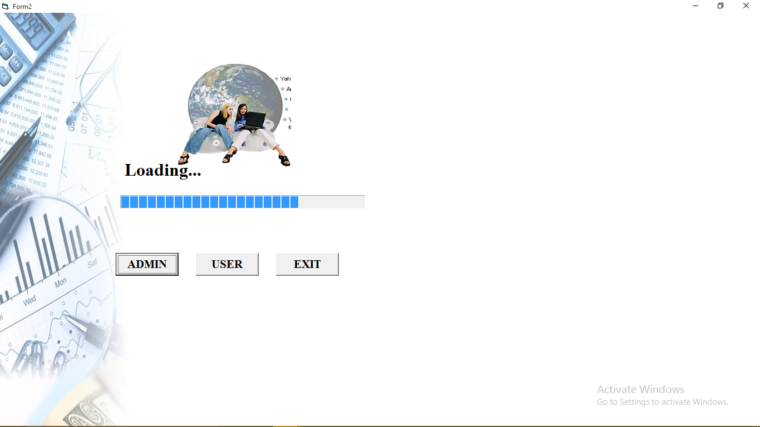

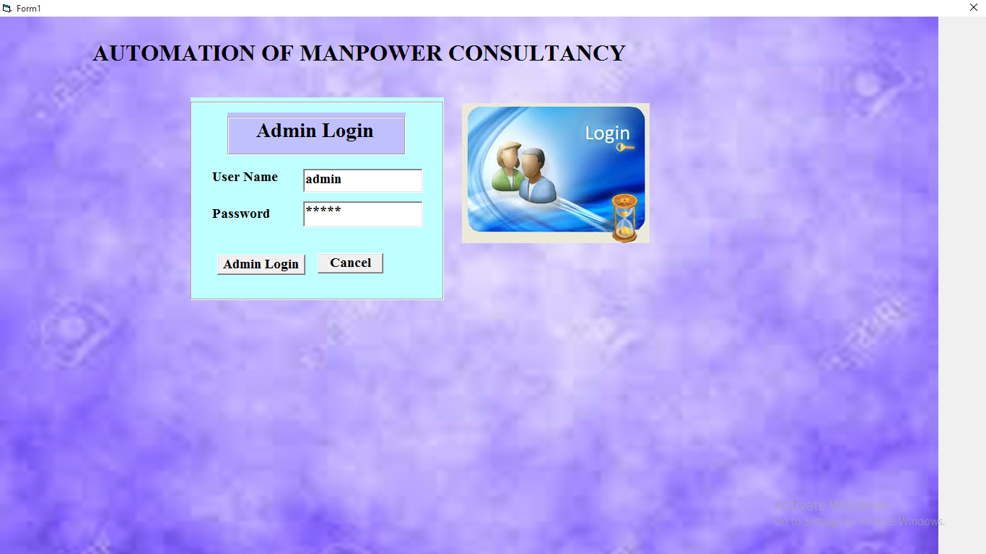

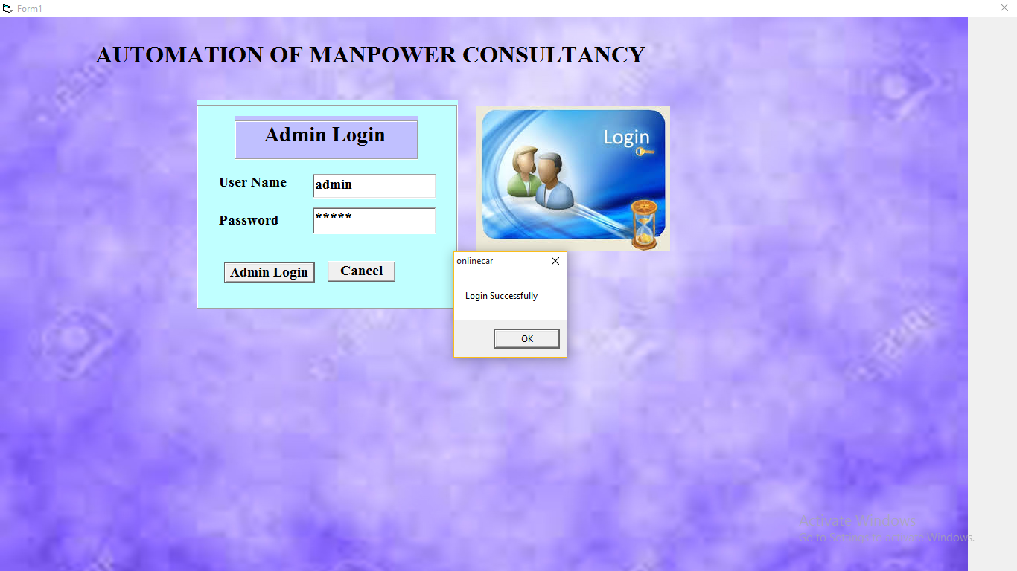

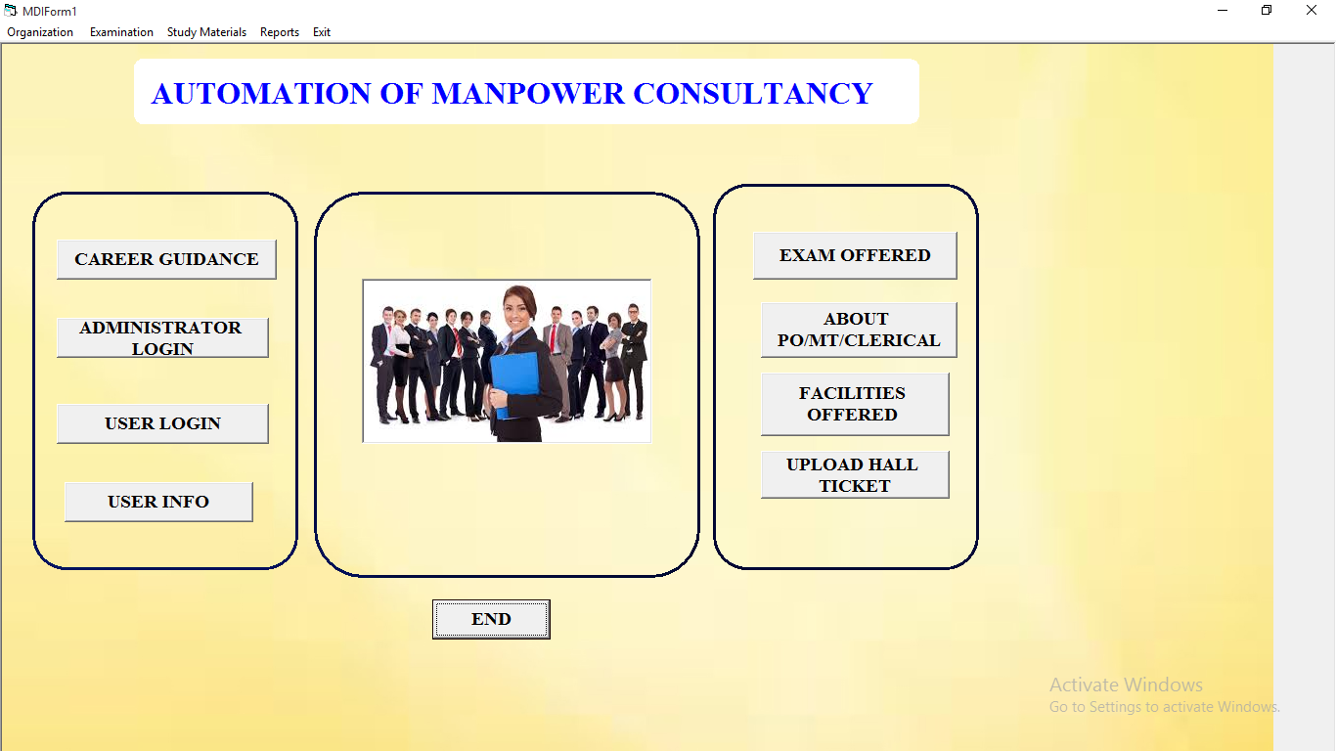

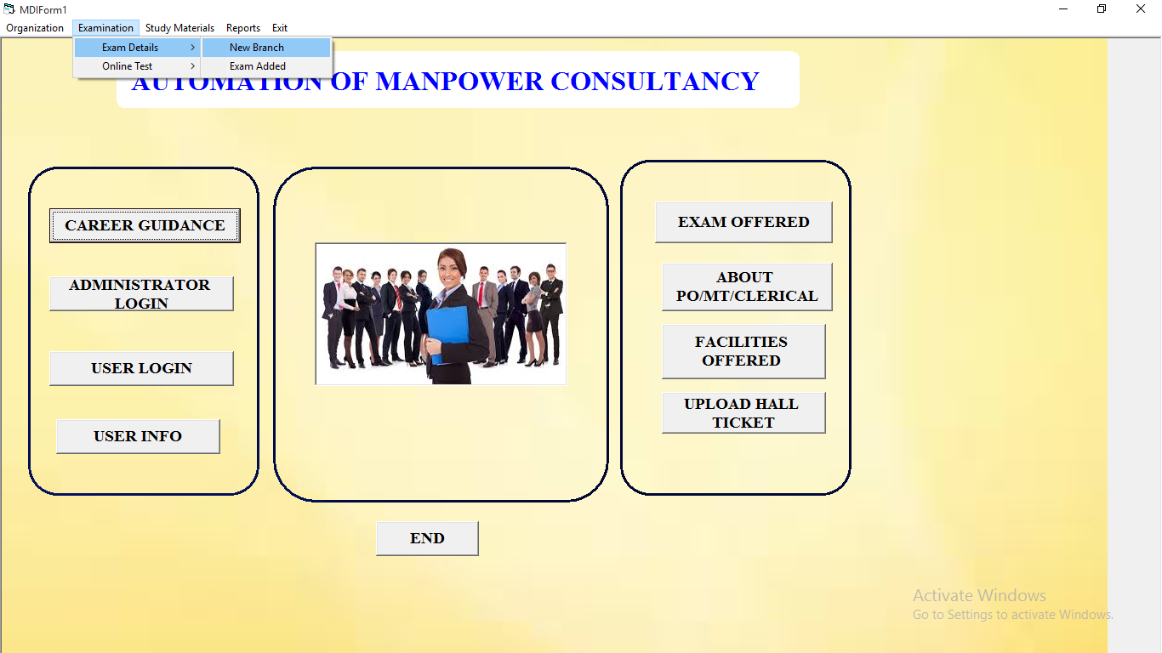

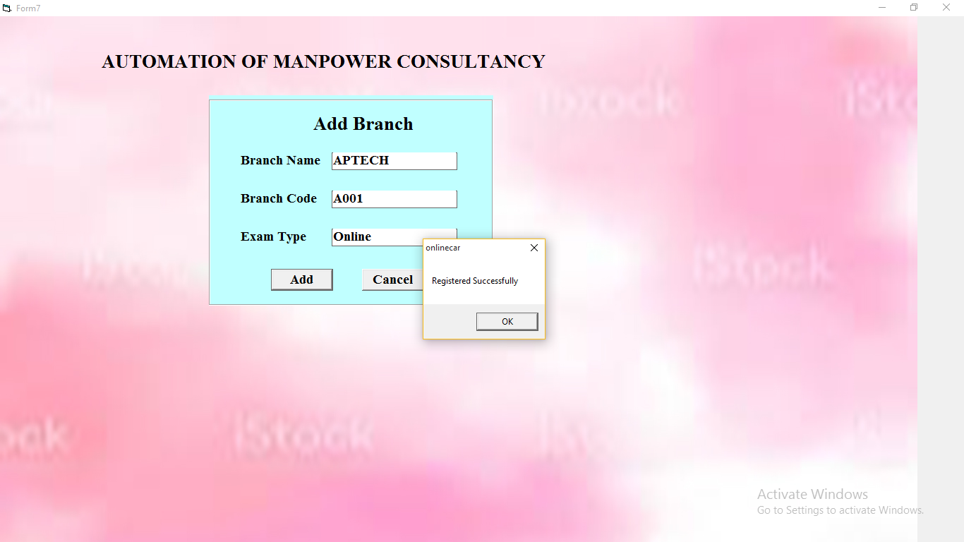

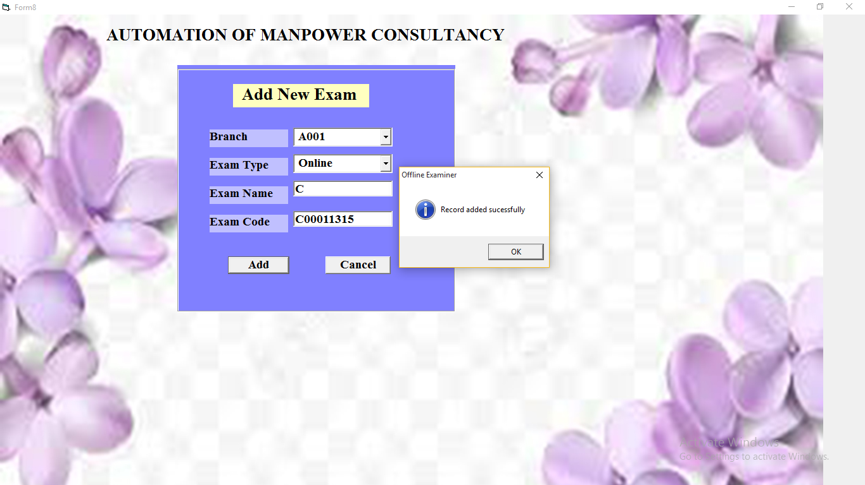

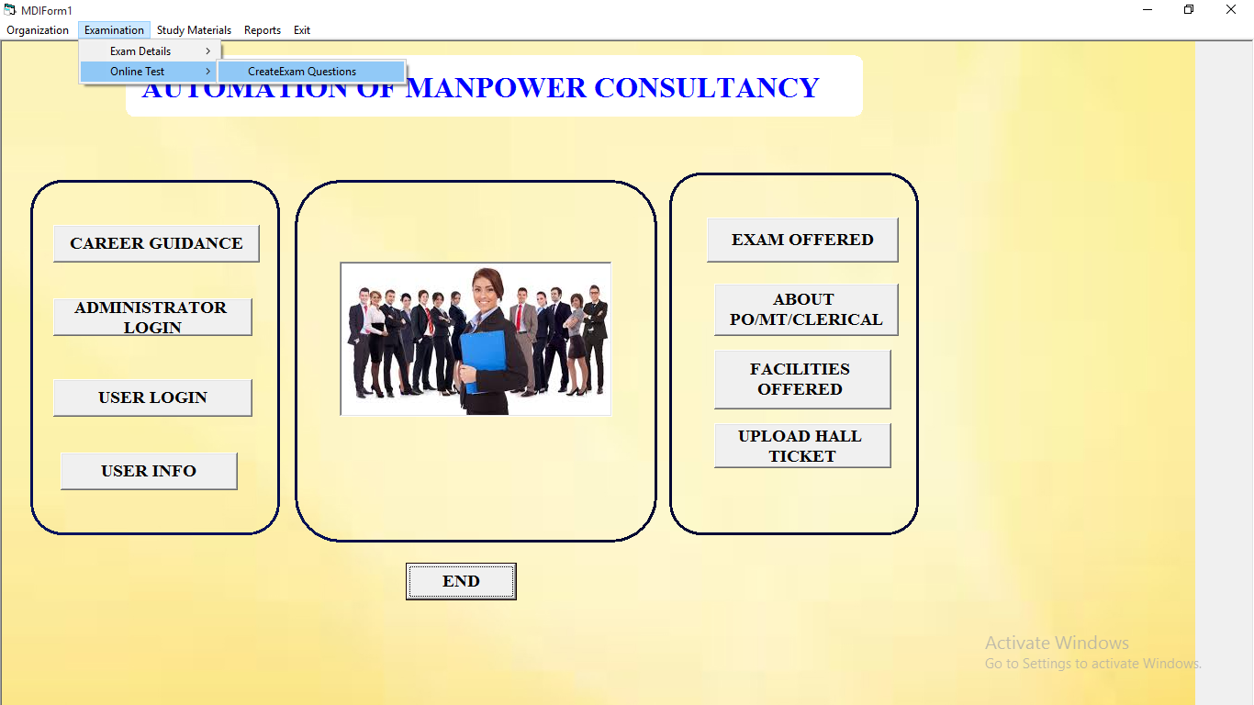

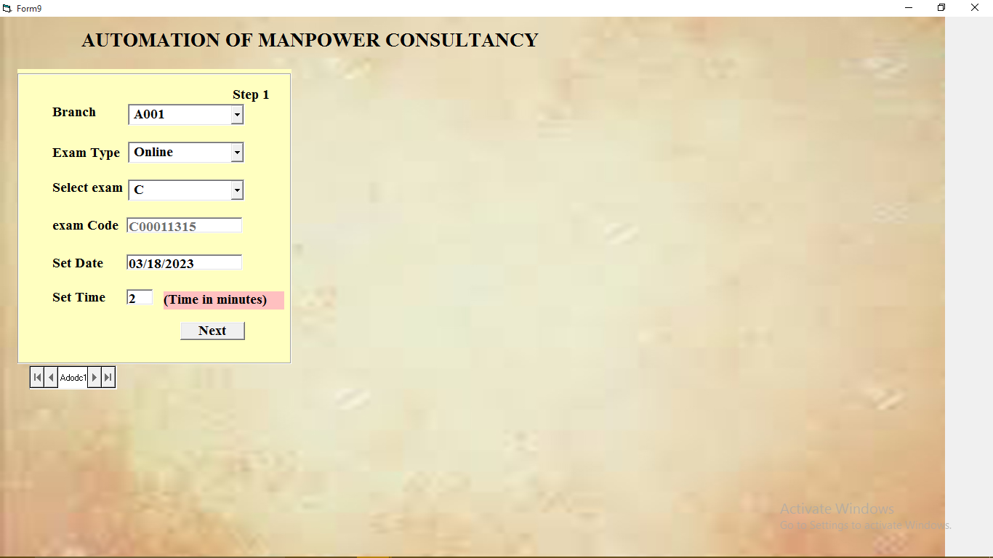

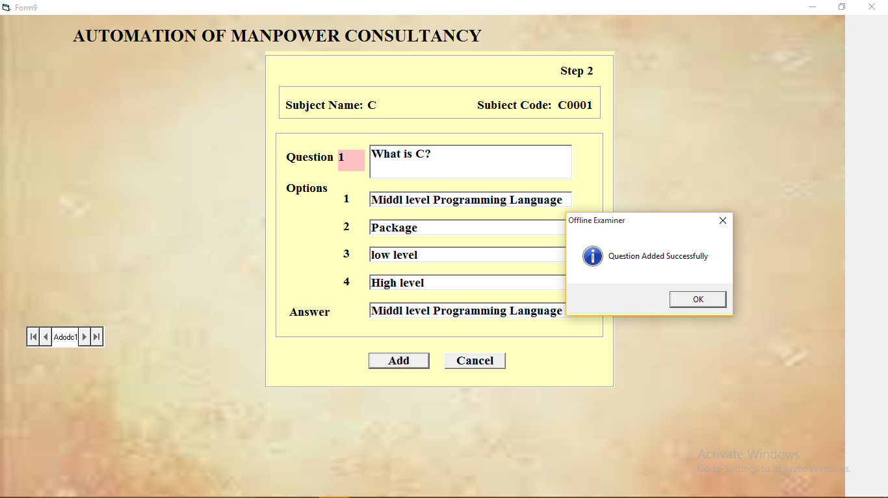

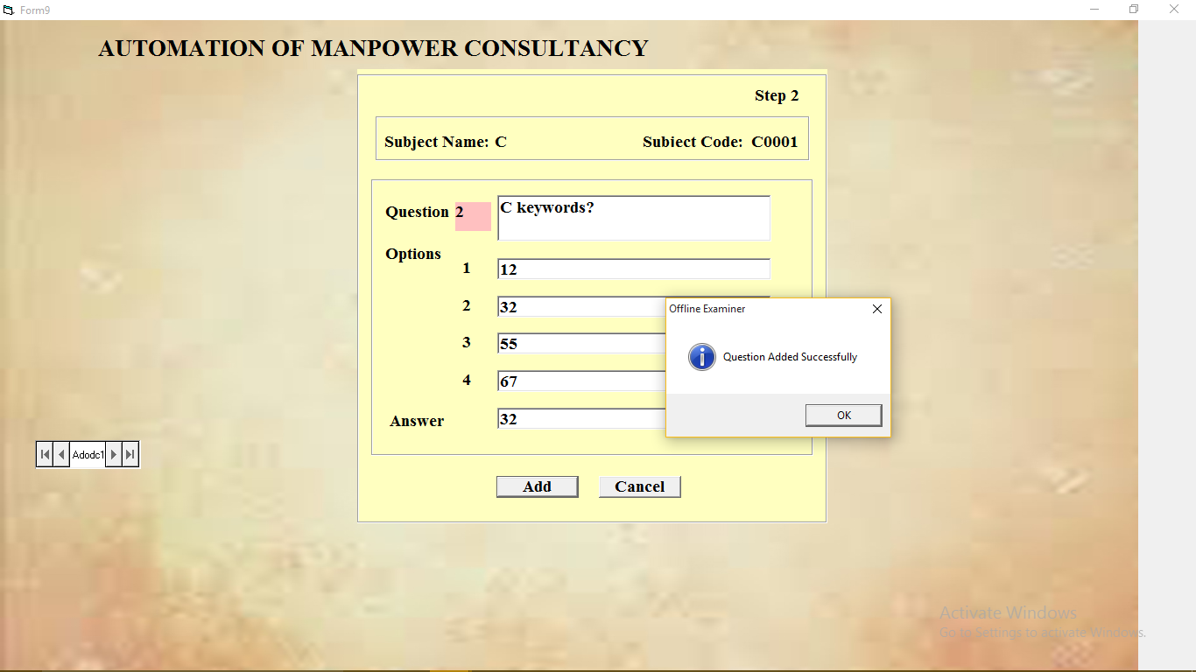

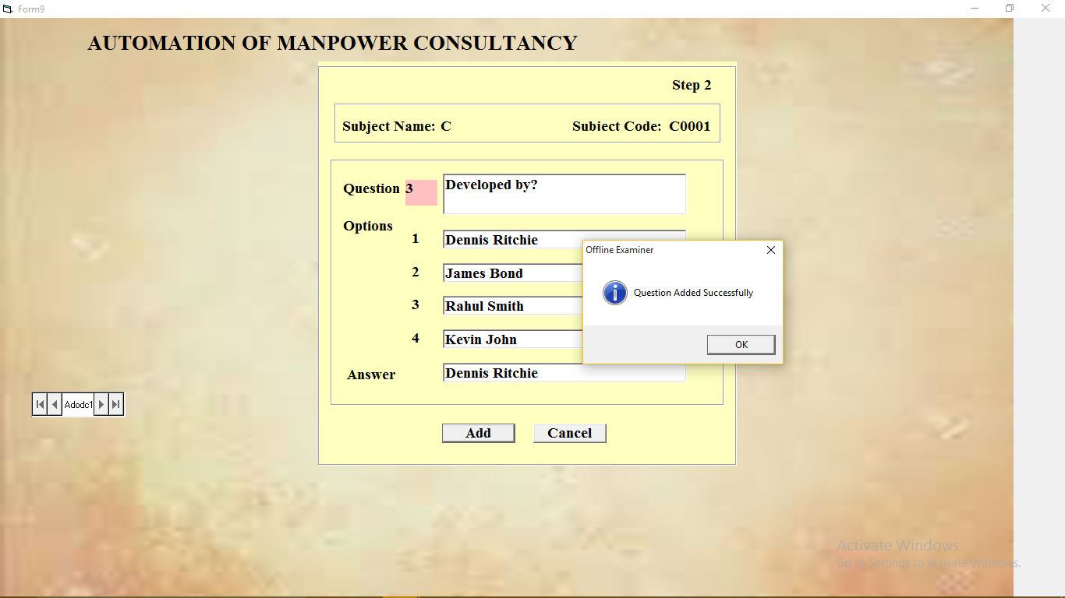





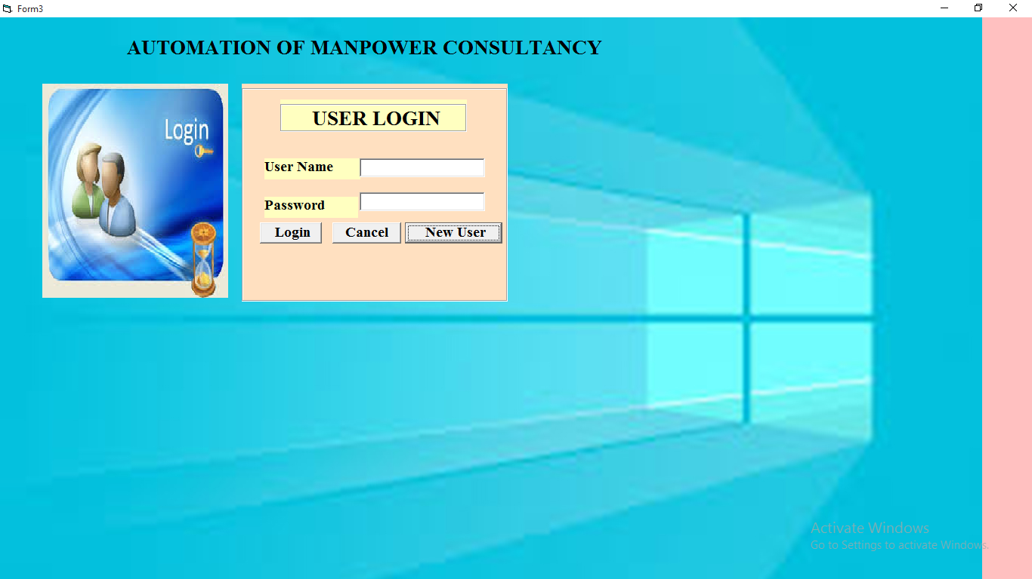

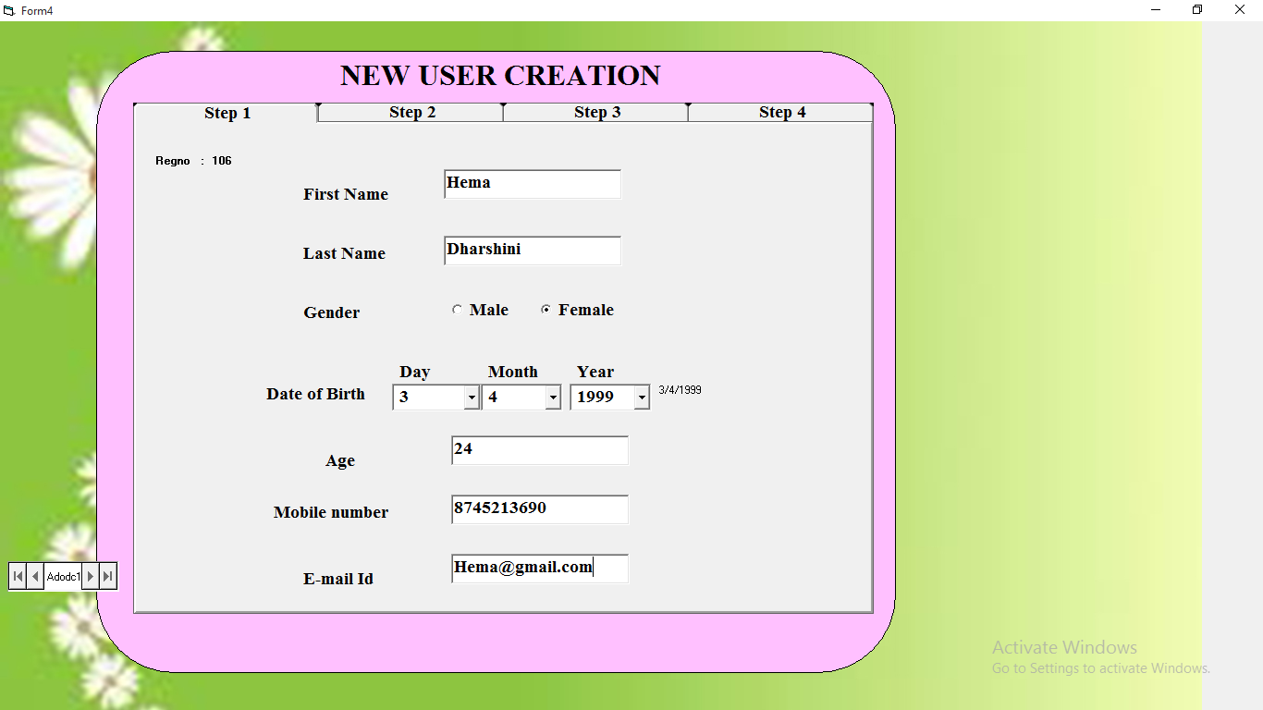

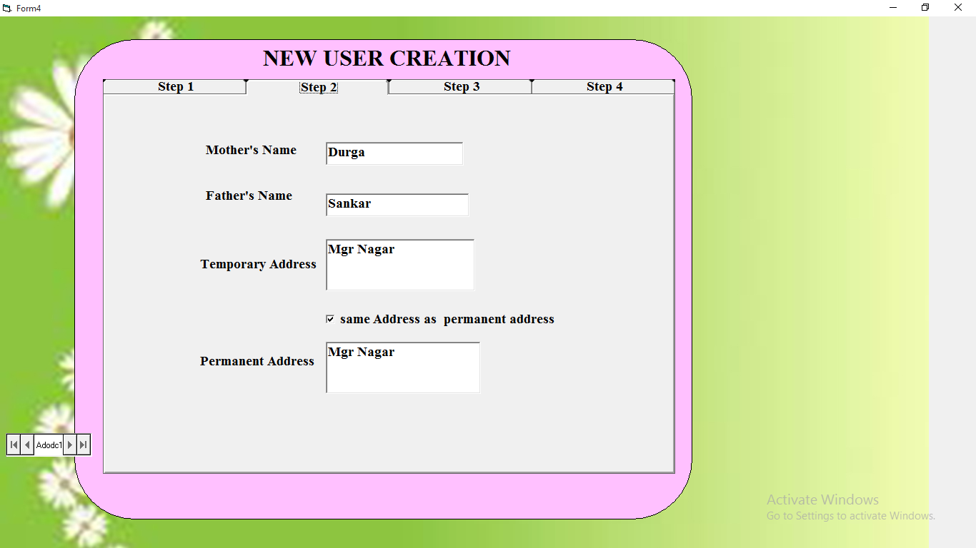

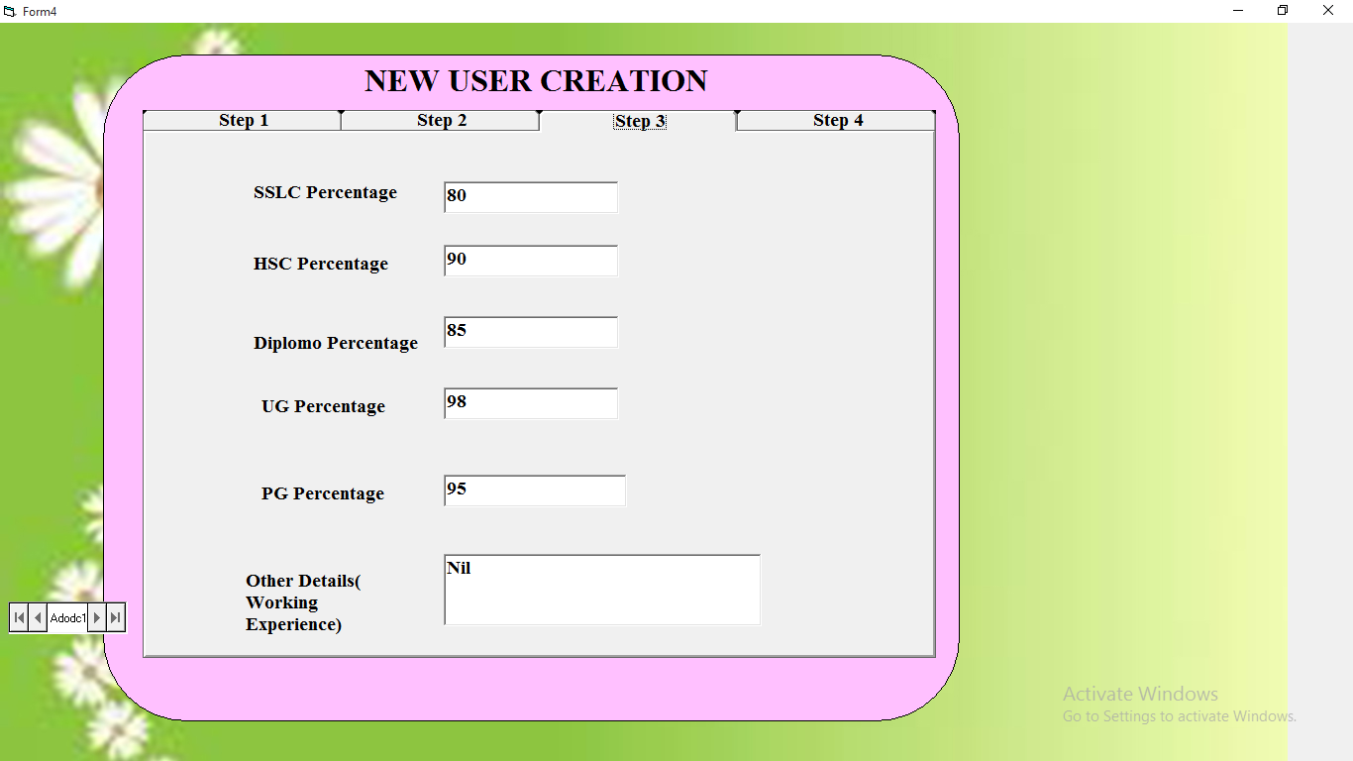

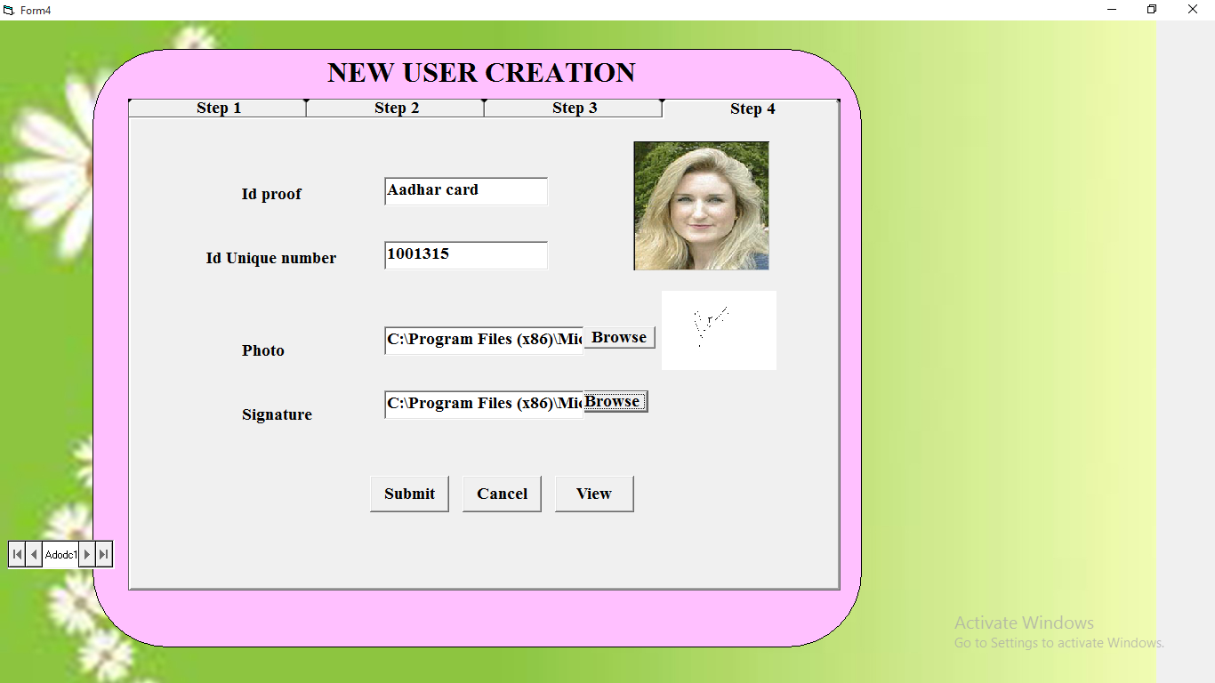

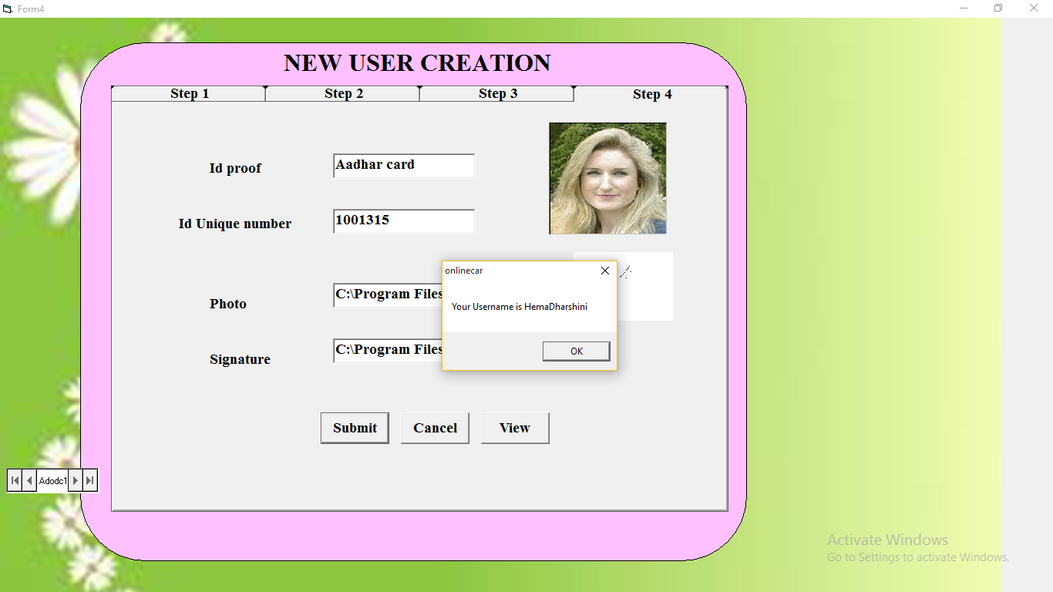

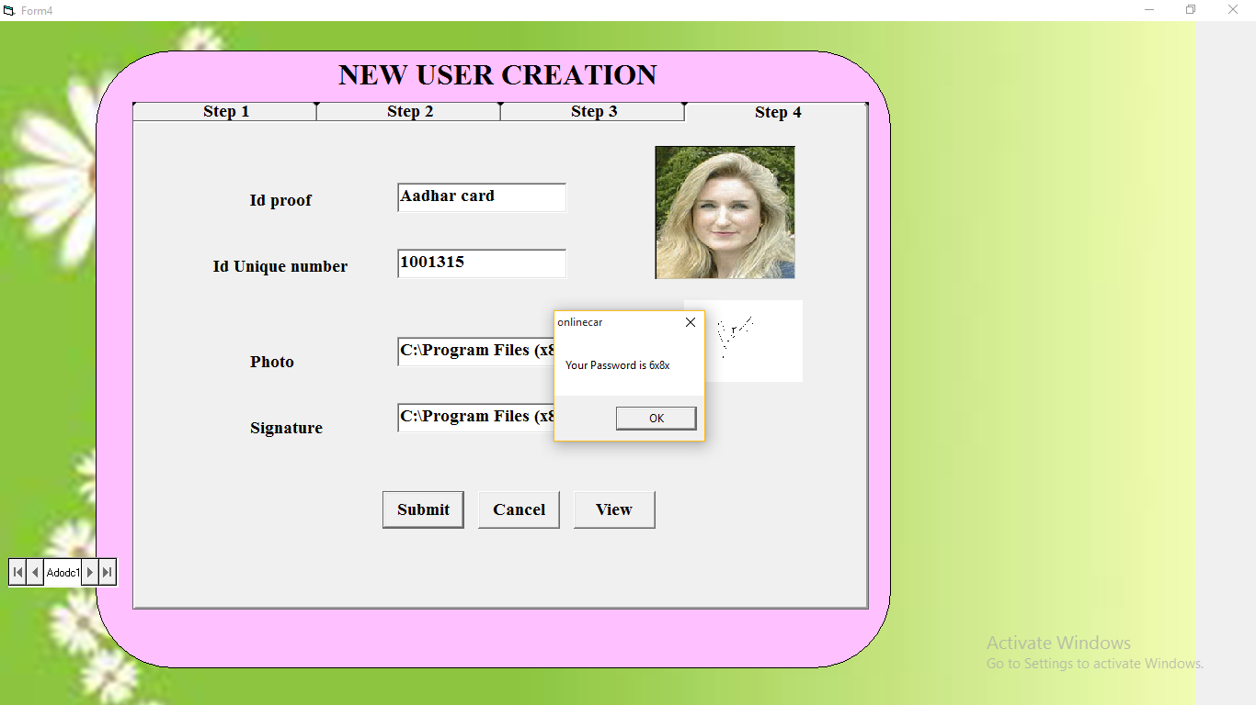

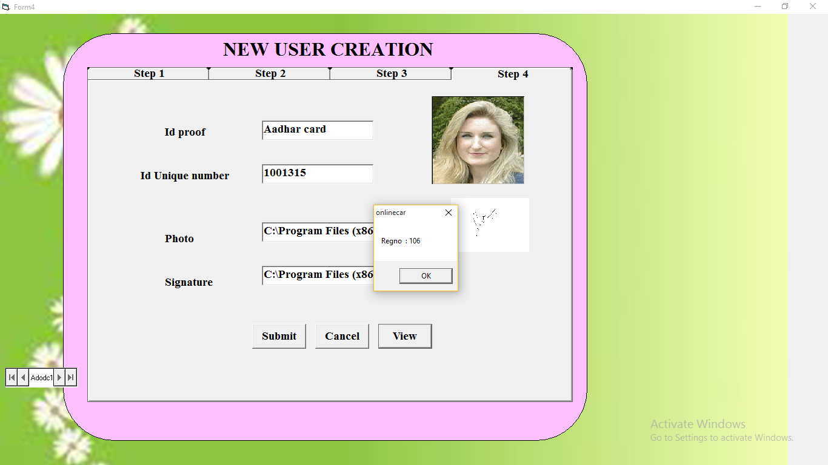

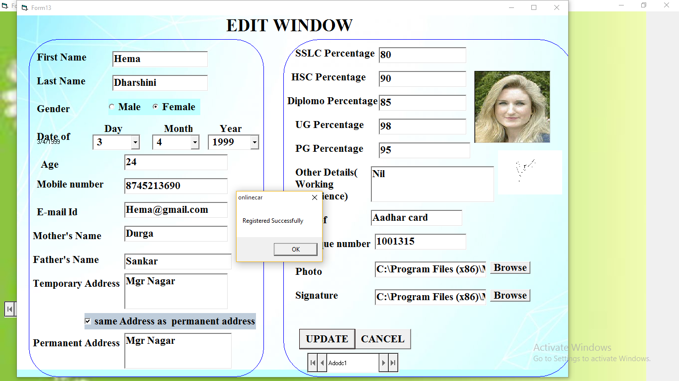

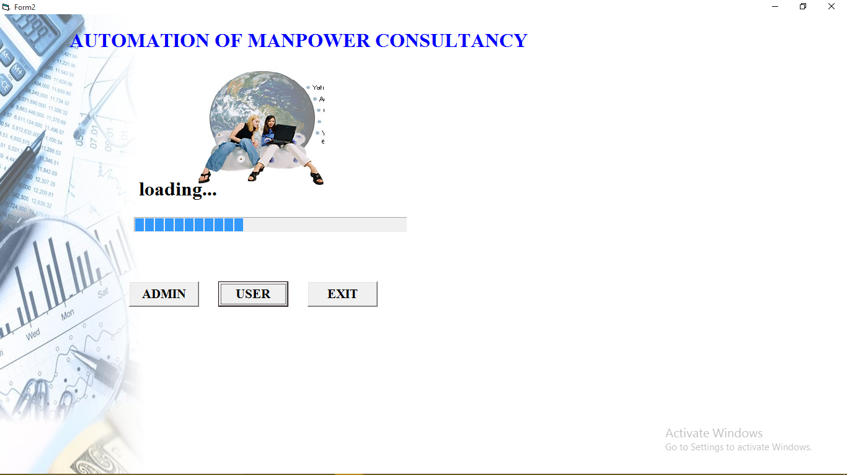

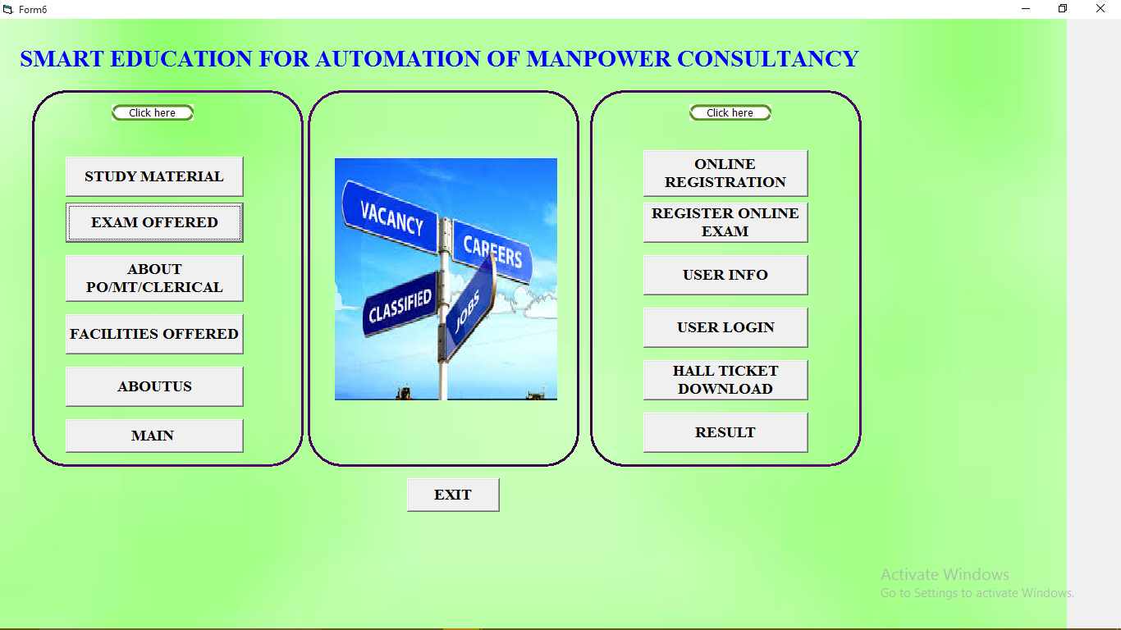

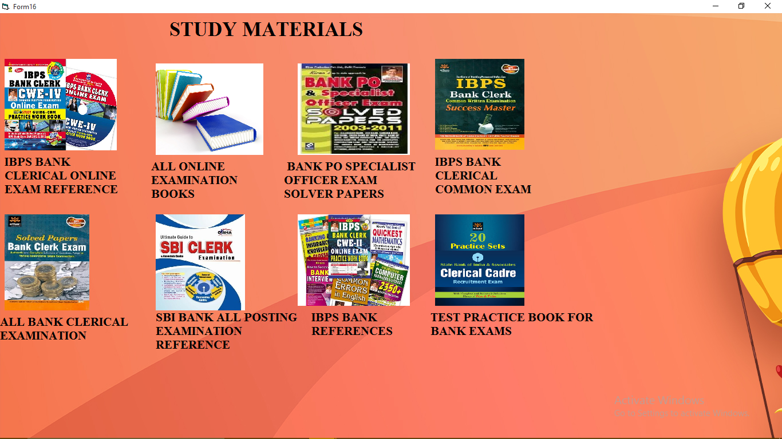

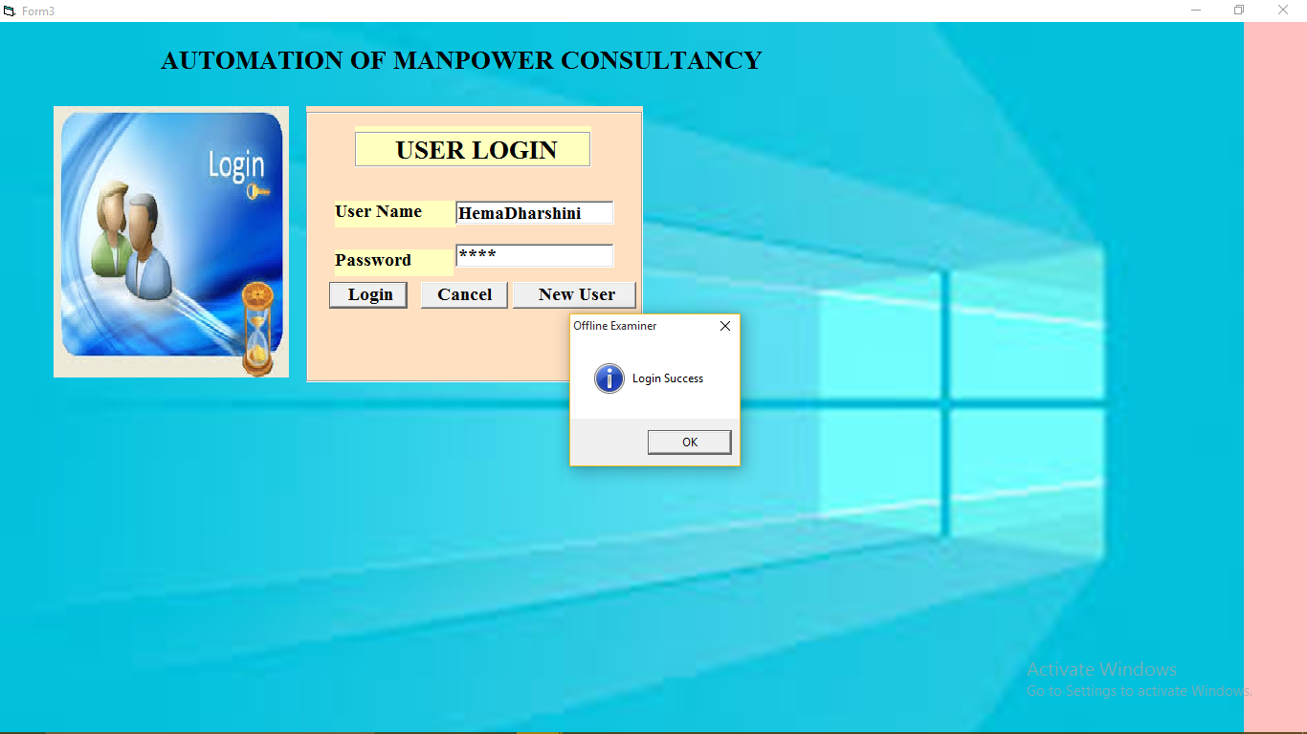

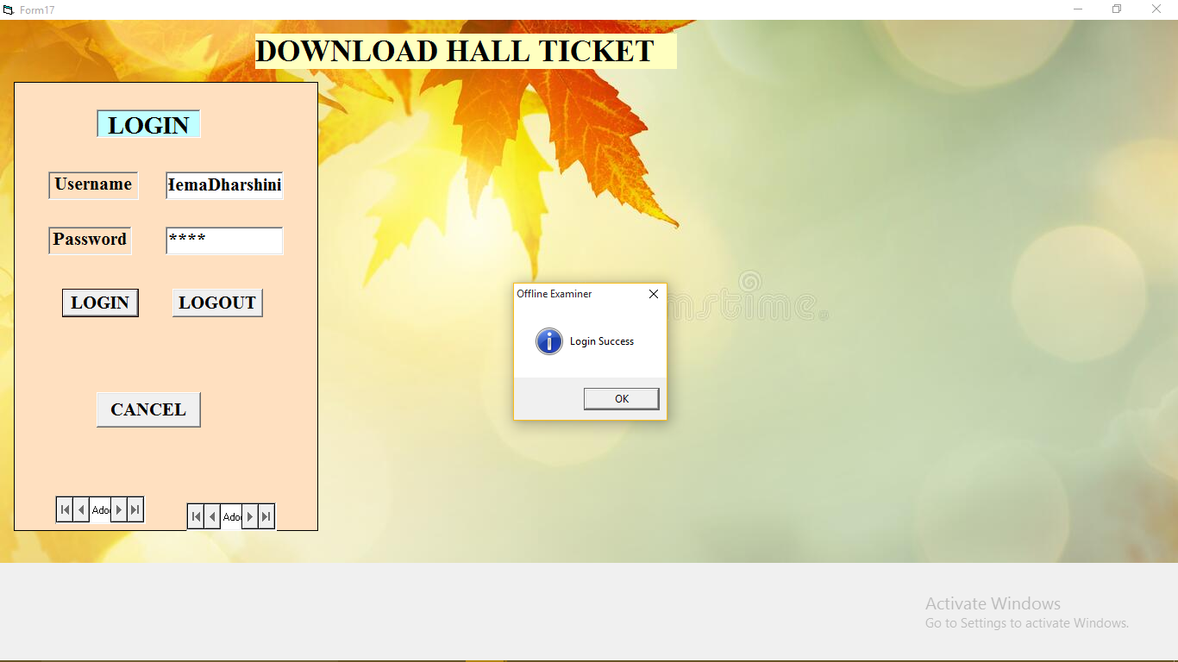

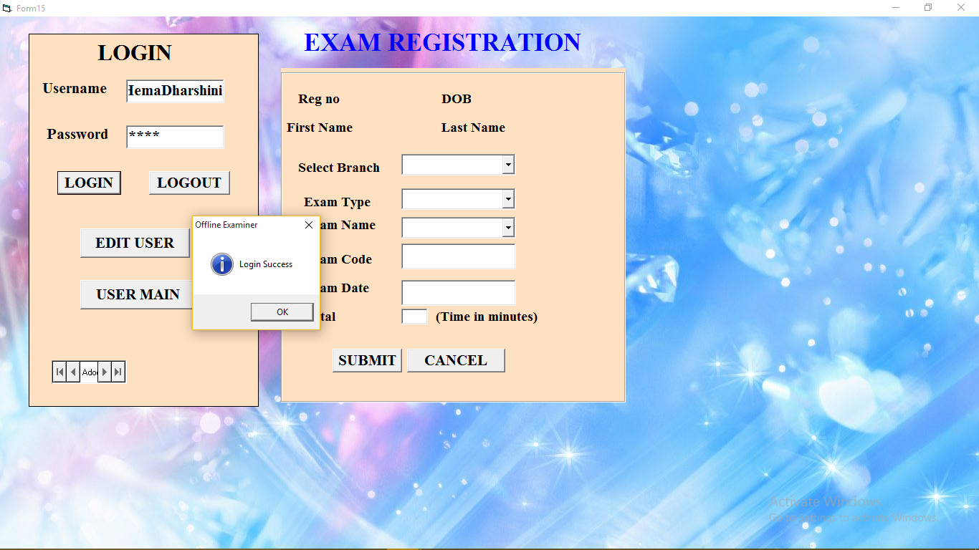

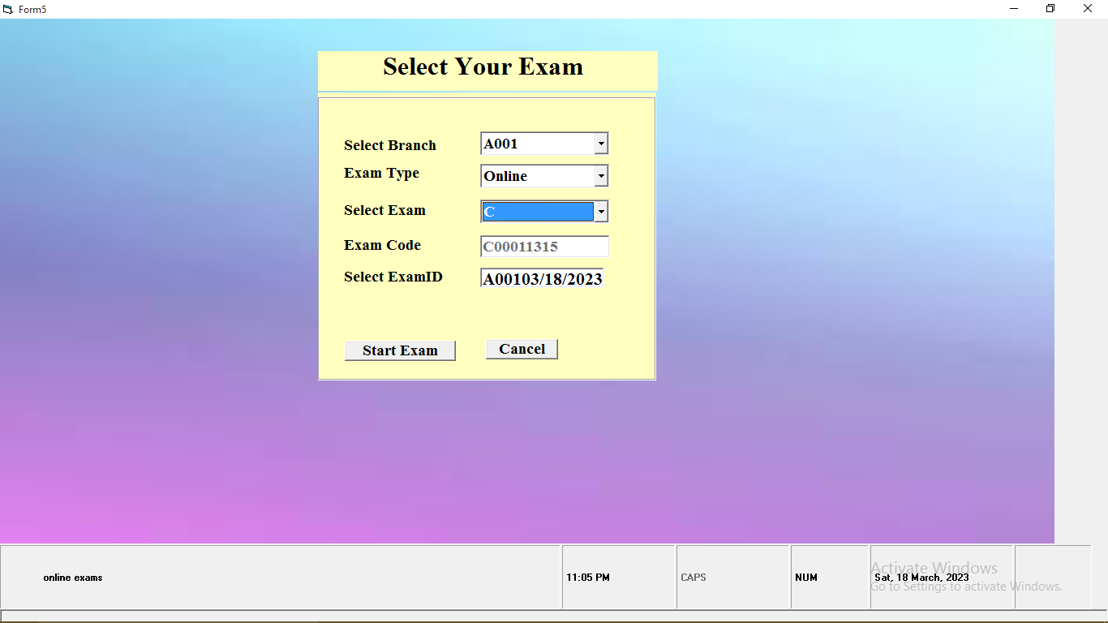

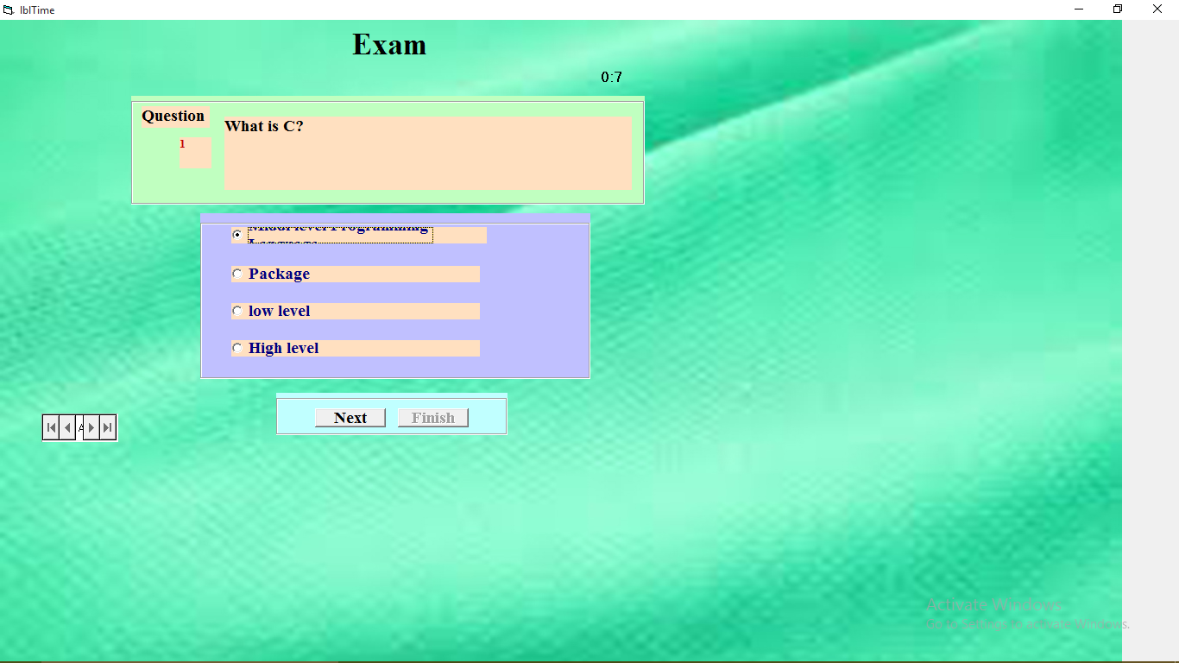

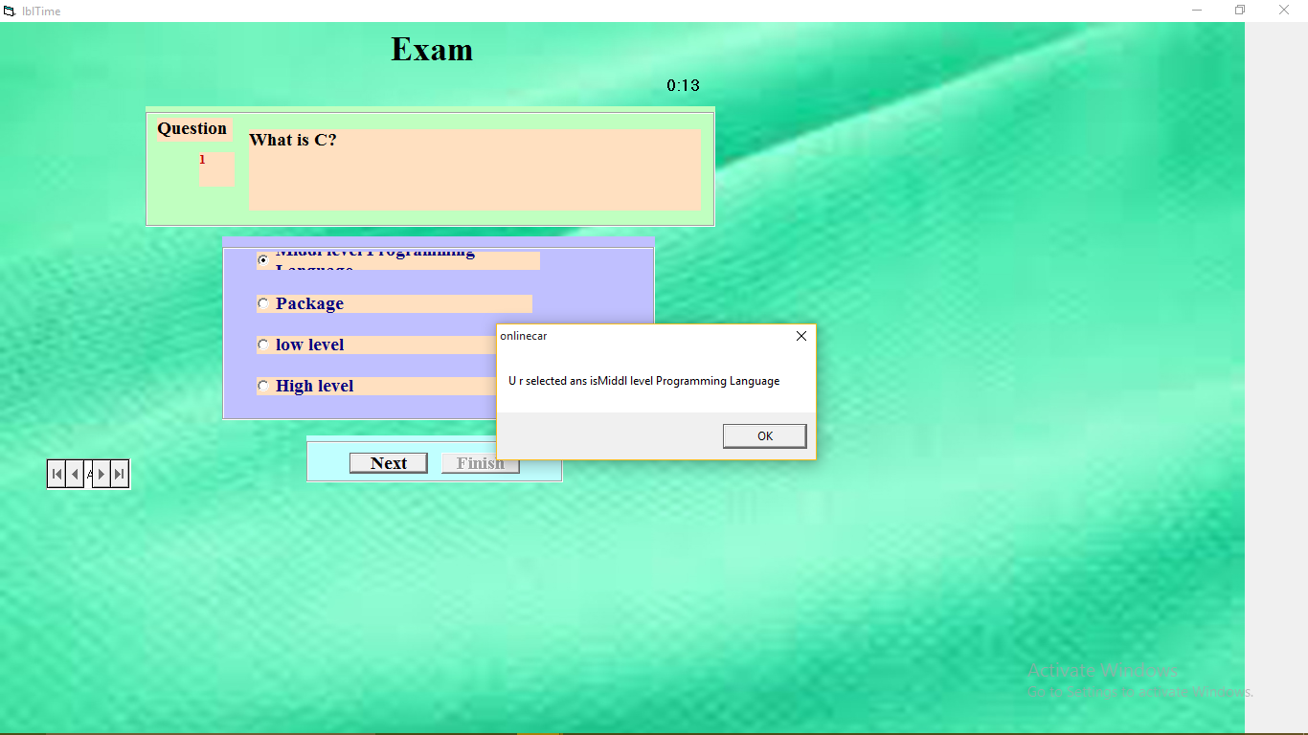

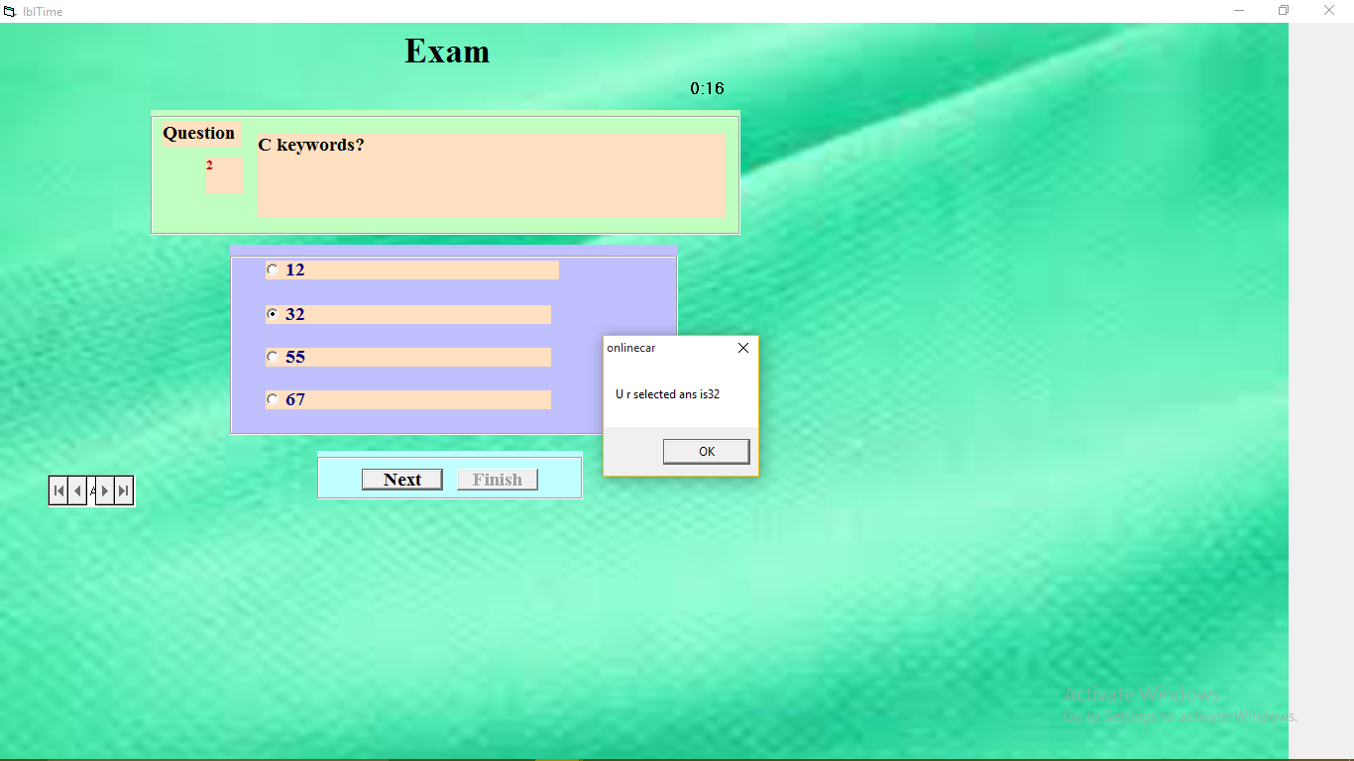

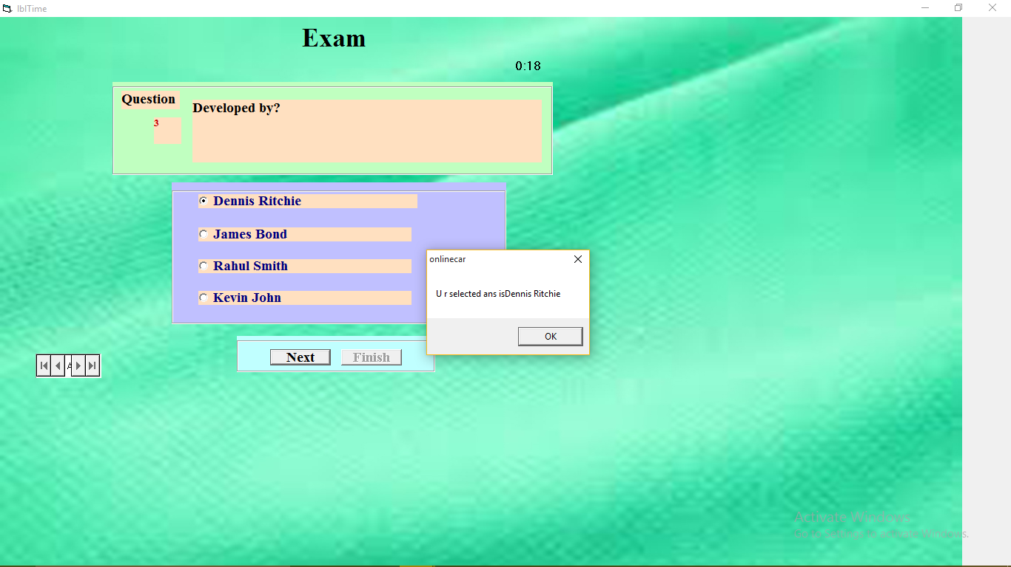

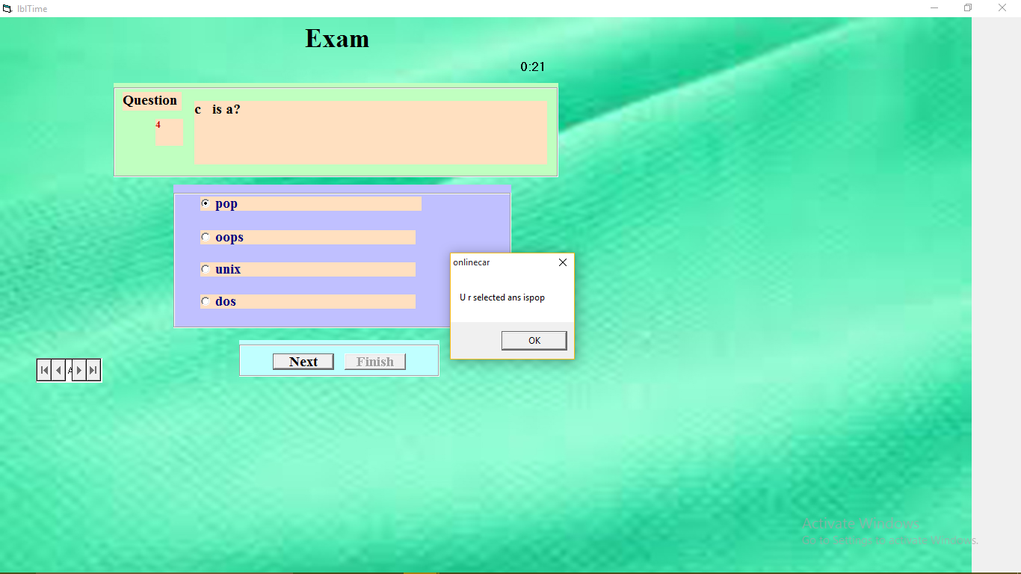

**8.3 REPORTS**

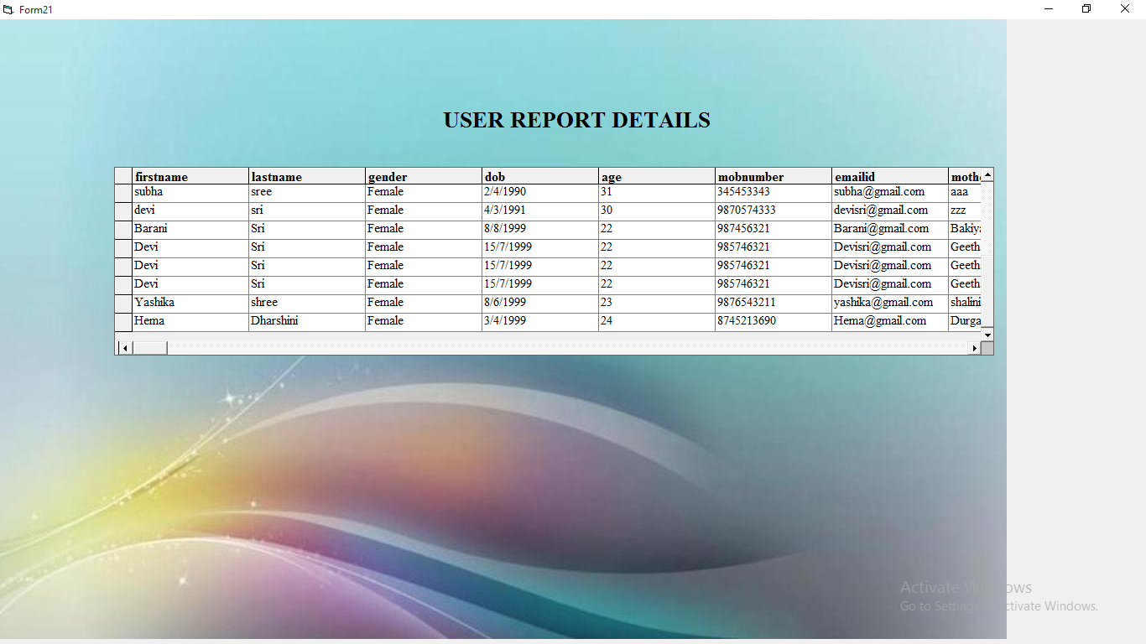

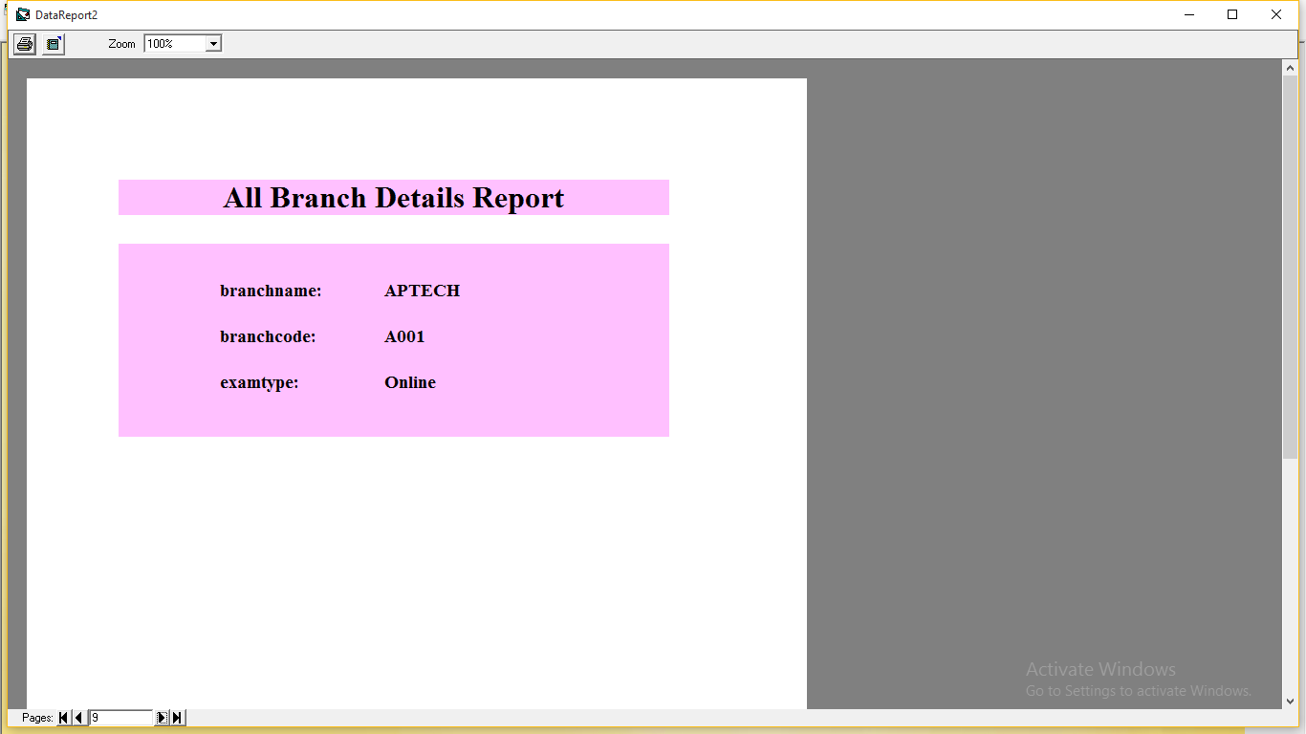

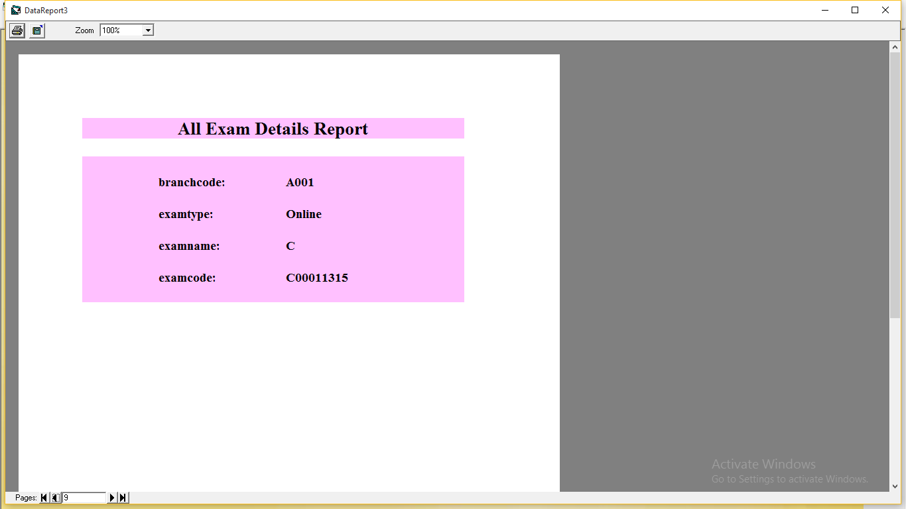



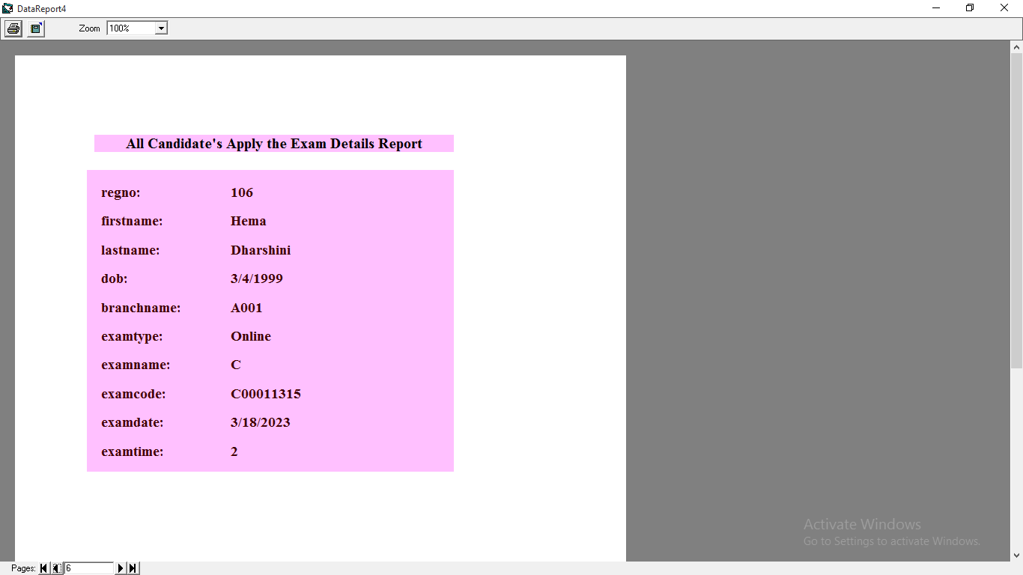

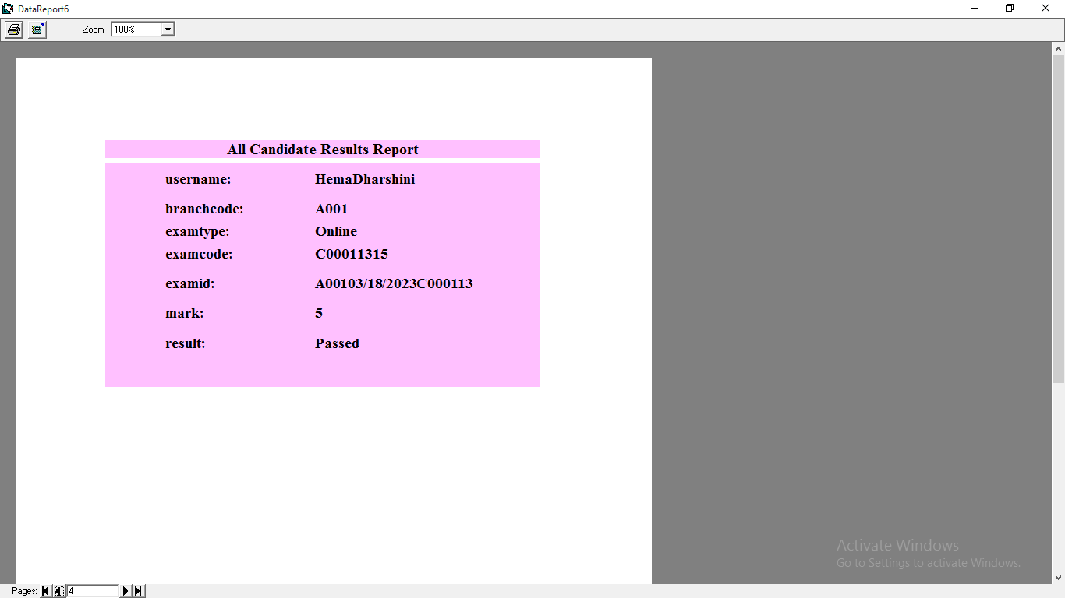

**BIBLIOGRAPHY**

1. **BIBLIOGRAPHY**

* VB Developer’s Handbook By Ken Getz And Mike Gilbert
* Database Access with Visual Basic Wayne S.Freeze
* Mastering Visual Basic 6.0 Evangelos Petroutsos
* MS Access by Ross Mistry.